Closed Path

Definition
# Source: AI Source: Provided by: [Data Path: Persons Table -> ID Column: 1, Name_En Column: Motasem Essam] -> From: [ChatGPT] on [7/25/2026]
A Closed Path is a geometric path whose starting point and ending point are the same point.
If a path starts at $A$and eventually returns to $A$, then:
$$\boxed{P_{\text{start}}=P_{\text{end}}}$$
For a parameterized path $r\left(t\right)$defined on $\left[a , b\right]$:
$$\boxed{r\left(a\right)=r\left(b\right)}$$
A closed path forms a complete loop or returns to its starting position.
Simple Definition
A Closed Path is a path that returns to its starting point.

Main Classification
# Source: AI Source: Provided by: [Data Path: Persons Table -> ID Column: 1, Name_En Column: Motasem Essam] -> From: [ChatGPT] on [7/25/2026]
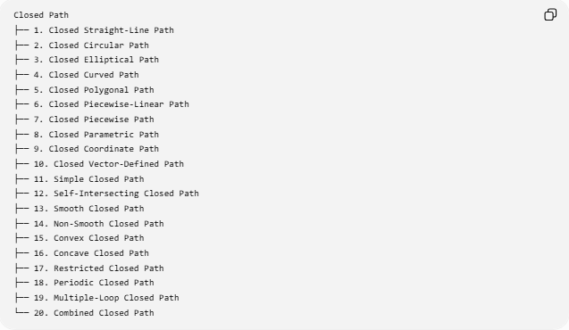
Closed Path
├── 1. Closed Straight-Line Path
├── 2. Closed Circular Path
├── 3. Closed Elliptical Path
├── 4. Closed Curved Path
├── 5. Closed Polygonal Path
├── 6. Closed Piecewise-Linear Path
├── 7. Closed Piecewise Path
├── 8. Closed Parametric Path
├── 9. Closed Coordinate Path
├── 10. Closed Vector-Defined Path
├── 11. Simple Closed Path
├── 12. Self-Intersecting Closed Path
├── 13. Smooth Closed Path
├── 14. Non-Smooth Closed Path
├── 15. Convex Closed Path
├── 16. Concave Closed Path
├── 17. Restricted Closed Path
├── 18. Periodic Closed Path
├── 19. Multiple-Loop Closed Path
└── 20. Combined Closed Path
Important: Some entries above are descriptive classifications rather than universally standardized mathematical categories. In particular, a non-degenerate single straight-line segment cannot itself be a closed path; “Closed Straight-Line Path” therefore refers to a closed path made from straight-line pieces, not one ordinary segment.

1. Closed Straight-Line Path
# Source: AI Source: Provided by: [Data Path: Persons Table -> ID Column: 1, Name_En Column: Motasem Essam] -> From: [ChatGPT] on [7/25/2026]
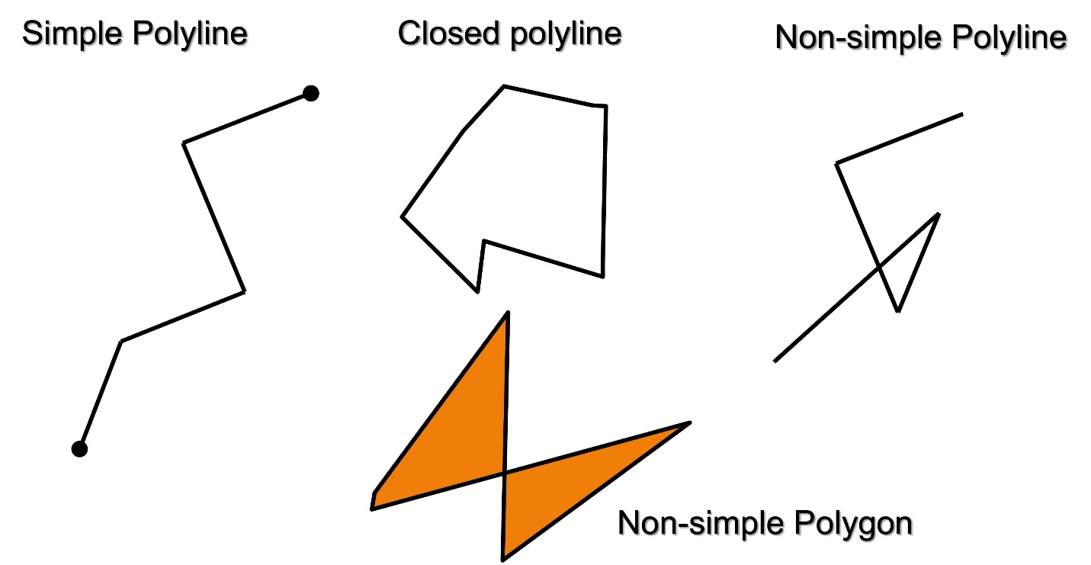
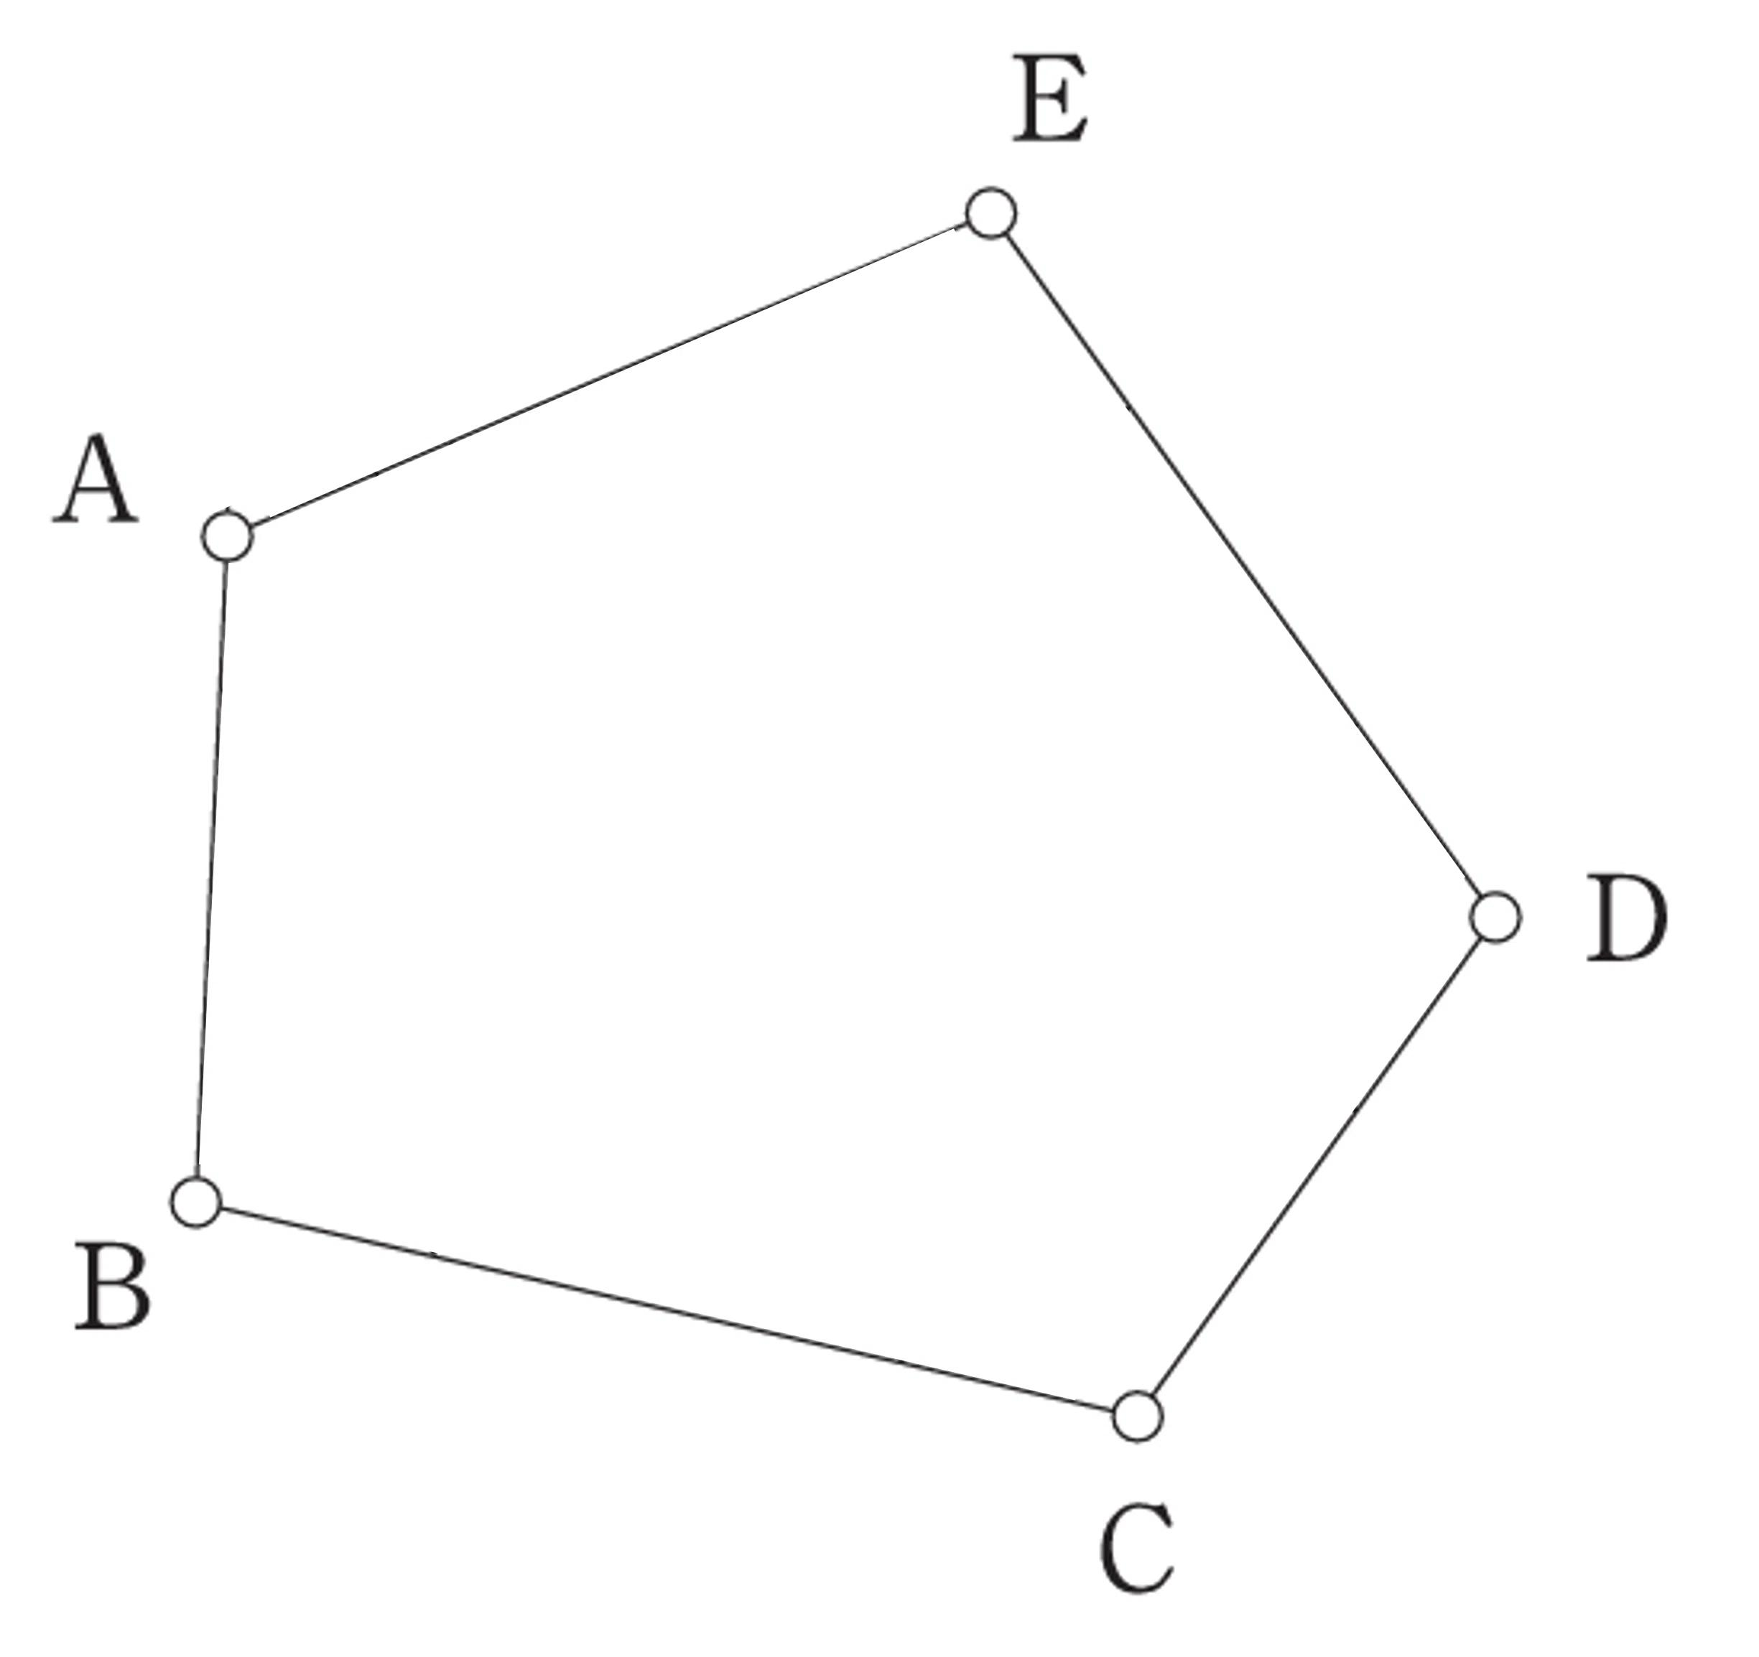
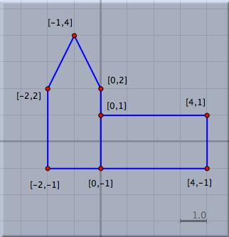
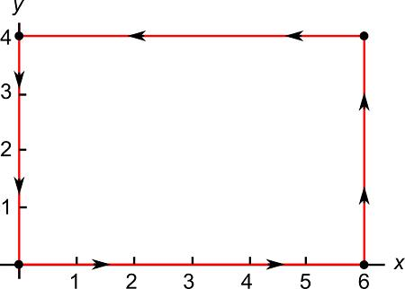
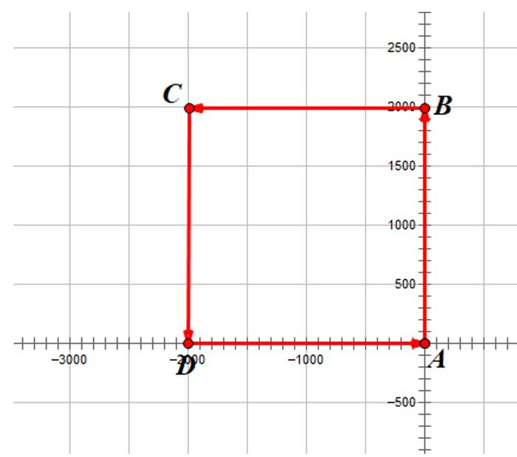
A Closed Straight-Line Path is a closed path composed entirely of straight-line segments.
A single nonzero straight segment cannot be closed, so at least three connected segments are normally required to create a non-degenerate closed path.
Example
$$A→B→C→A$$
forms a triangular closed path.
Important Relationship
A closed polygonal path is the standard example of a closed path made entirely from straight segments.

2. Closed Circular Path
# Source: AI Source: Provided by: [Data Path: Persons Table -> ID Column: 1, Name_En Column: Motasem Essam] -> From: [ChatGPT] on [7/25/2026]
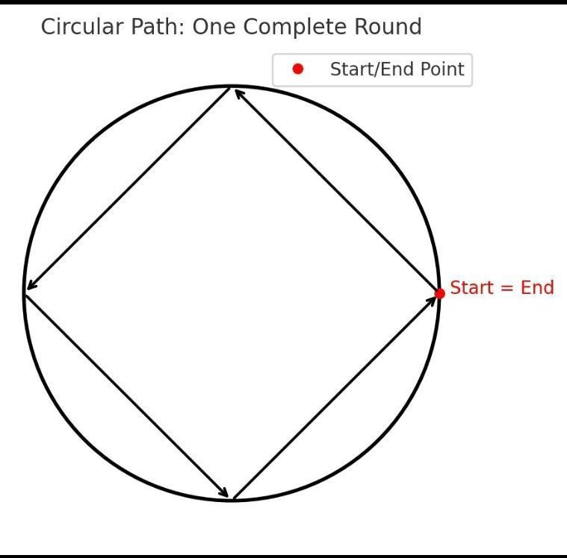
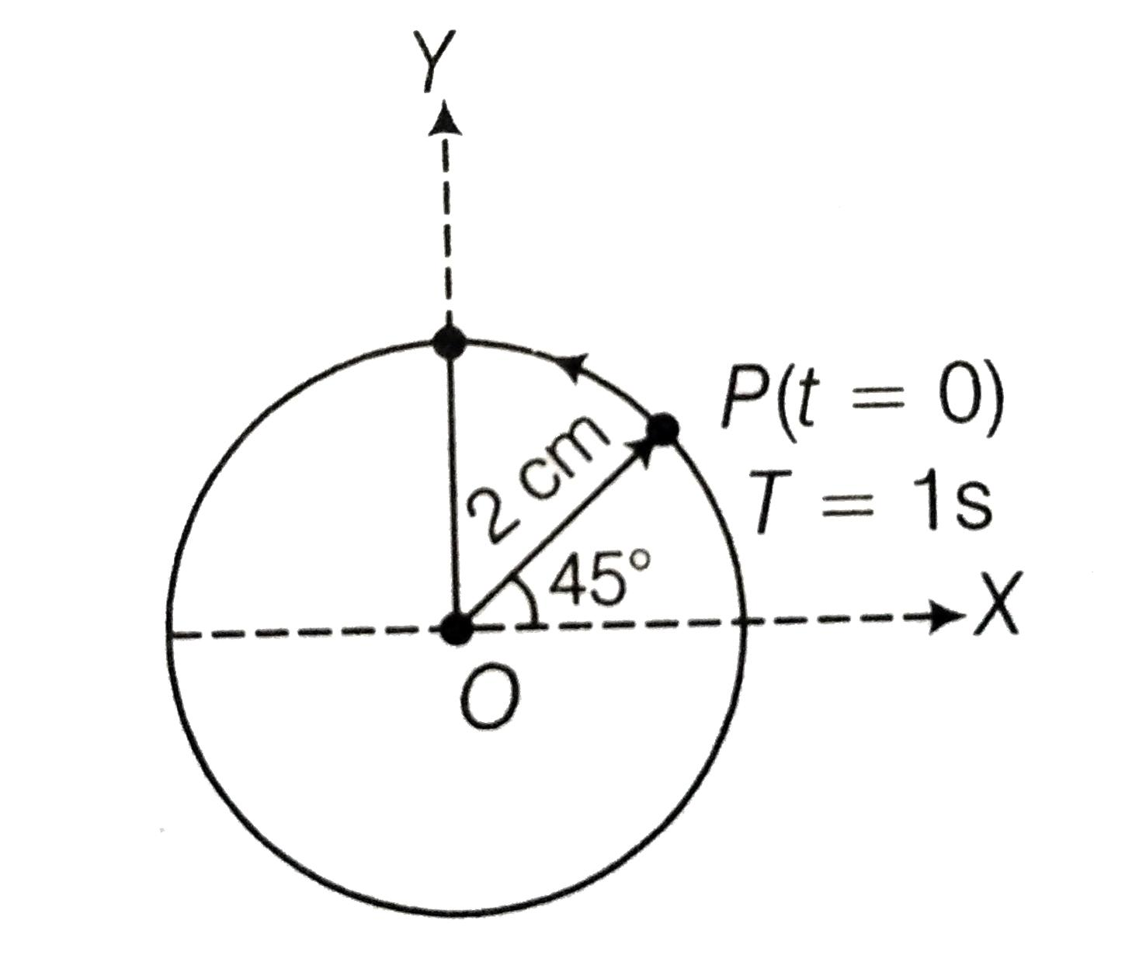
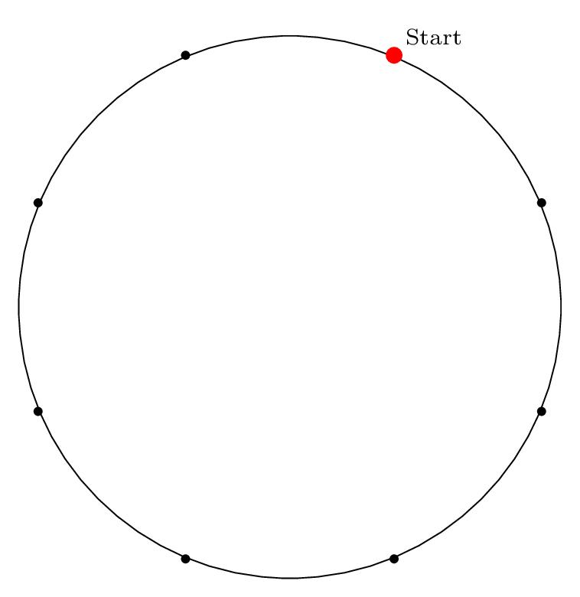
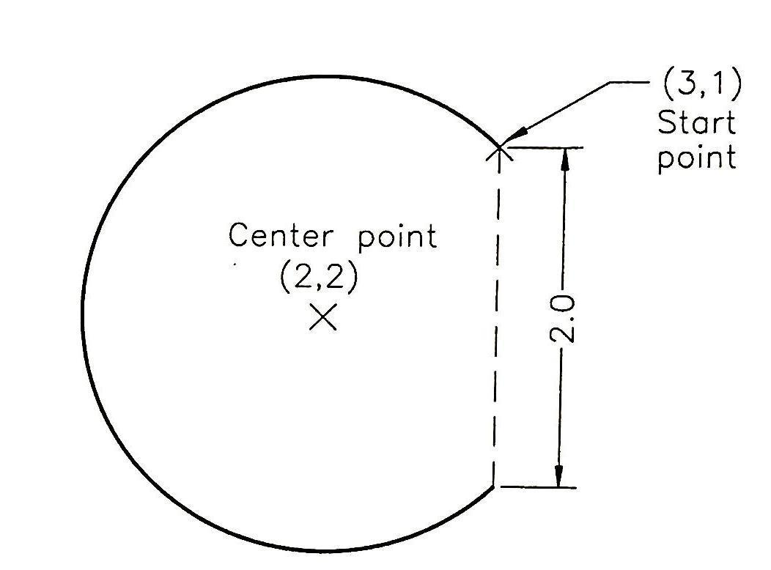
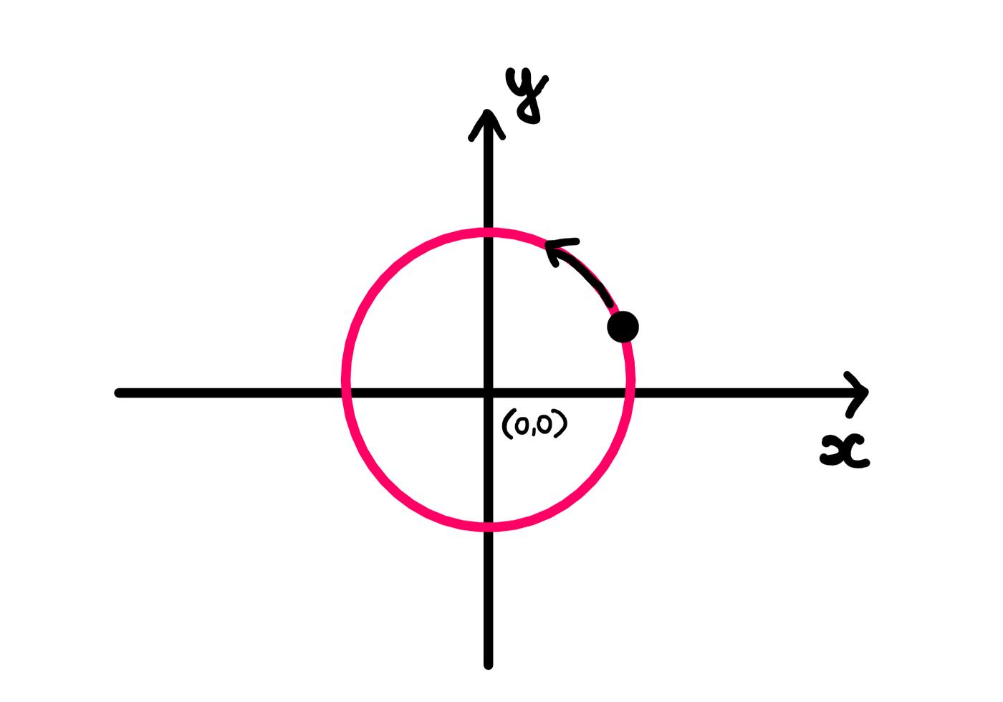
A Closed Circular Path is a complete circular path that returns to its starting point.
For a circle with center $O$:
$$\boxed{OP=r}$$
A complete traversal covers:
$${360}^{∘}=2π.$$
Example
$$x=r\cos{t}, y=r\sin{t}, 0≤t≤2π.$$
Since
$$r\left(0\right)=r\left(2π\right),$$
the path is closed.
Circumference
$$\boxed{L=2πr}$$

3. Closed Elliptical Path
# Source: AI Source: Provided by: [Data Path: Persons Table -> ID Column: 1, Name_En Column: Motasem Essam] -> From: [ChatGPT] on [7/25/2026]
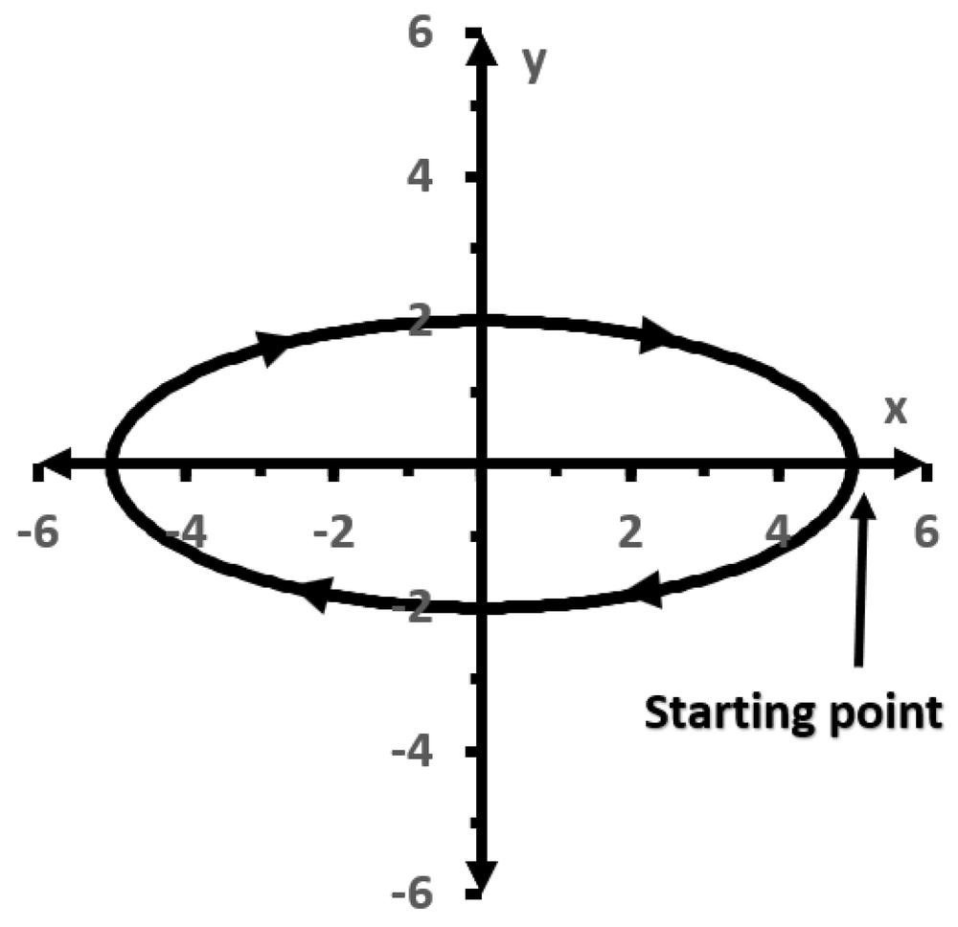
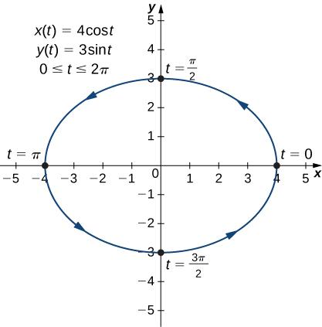
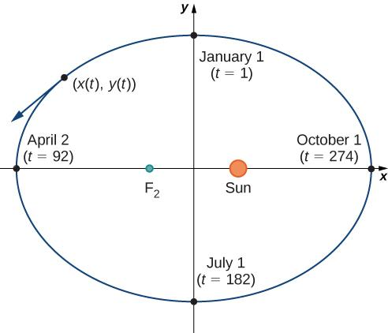
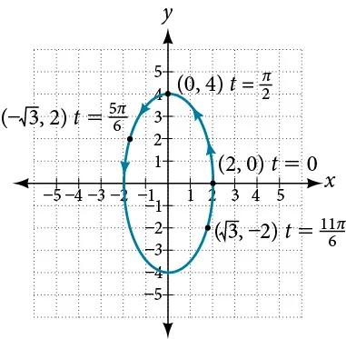
A Closed Elliptical Path follows a complete ellipse and returns to its starting point.
A standard parameterization is:
$$\boxed{x=a\cos{t}, y=b\sin{t}}$$
for
$$0≤t≤2π.$$
Example
$$x=5\cos{t}, y=3\sin{t}.$$
The path begins and ends at:
$$\left(5 , 0\right).$$
Thus:
$$\boxed{r\left(0\right)=r\left(2π\right)}.$$

4. Closed Curved Path
# Source: AI Source: Provided by: [Data Path: Persons Table -> ID Column: 1, Name_En Column: Motasem Essam] -> From: [ChatGPT] on [7/25/2026]
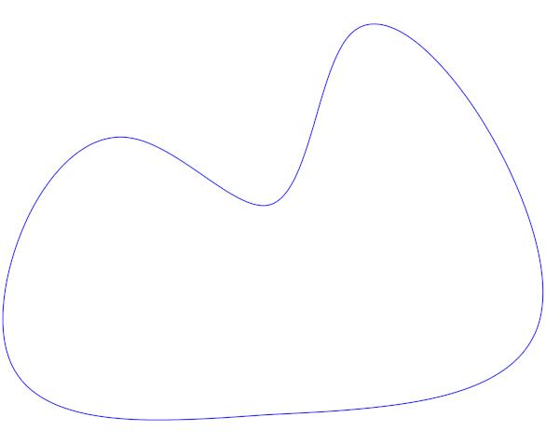
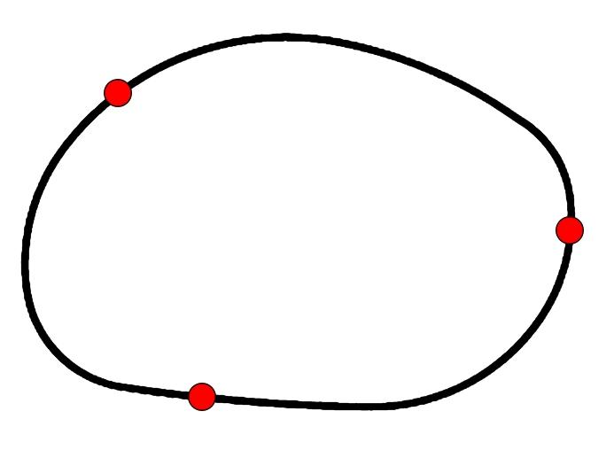
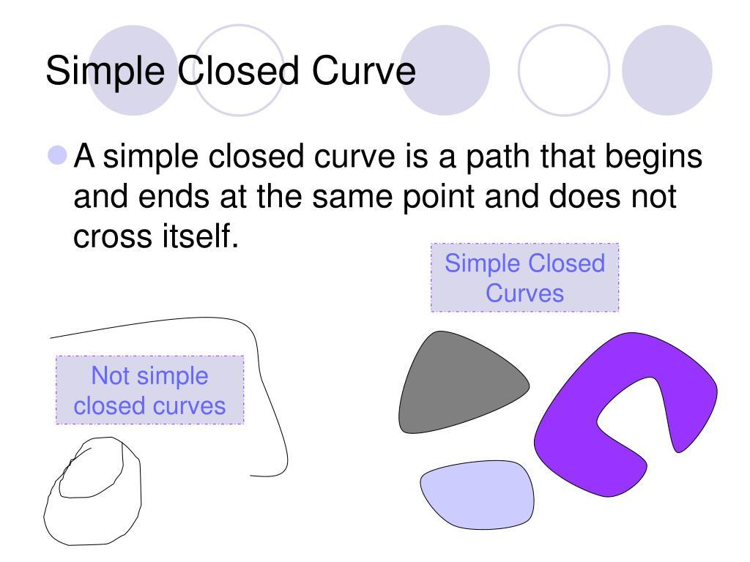
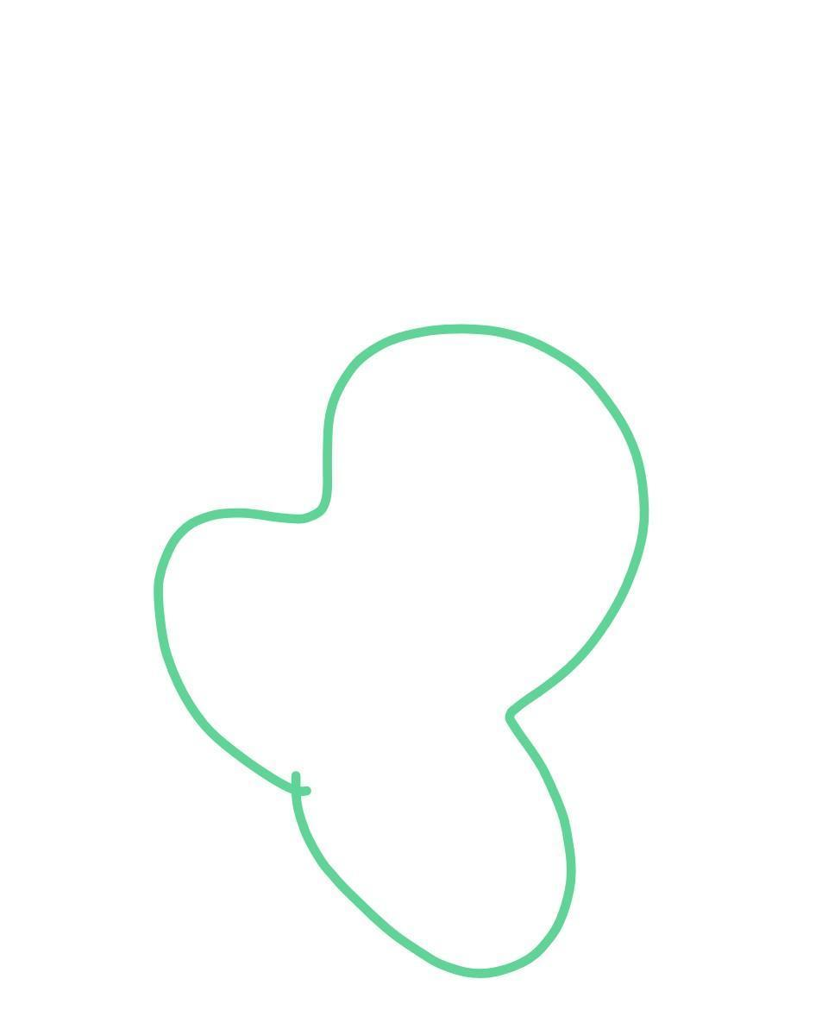
A Closed Curved Path is any curved path that eventually returns to its starting point.
It does not have to be circular or elliptical.
Examples
- circle
- ellipse
- smooth closed loop
- closed freeform curve
The defining condition remains:
$$\boxed{P_{\text{start}}=P_{\text{end}}}.$$

5. Closed Polygonal Path
# Source: AI Source: Provided by: [Data Path: Persons Table -> ID Column: 1, Name_En Column: Motasem Essam] -> From: [ChatGPT] on [7/25/2026]
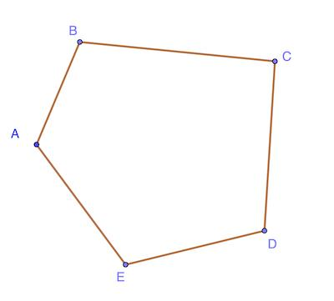
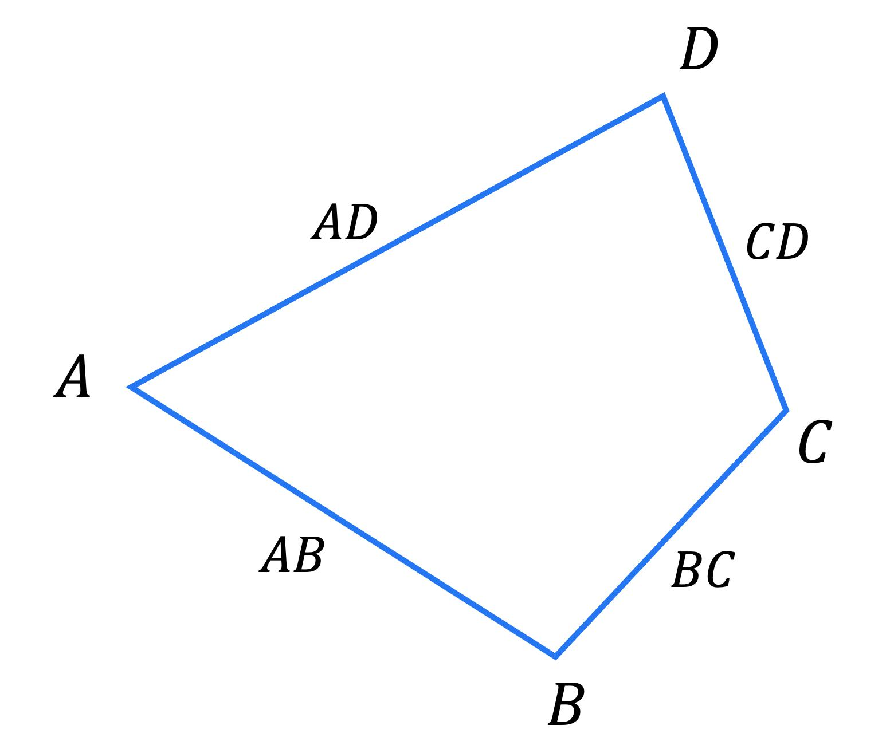
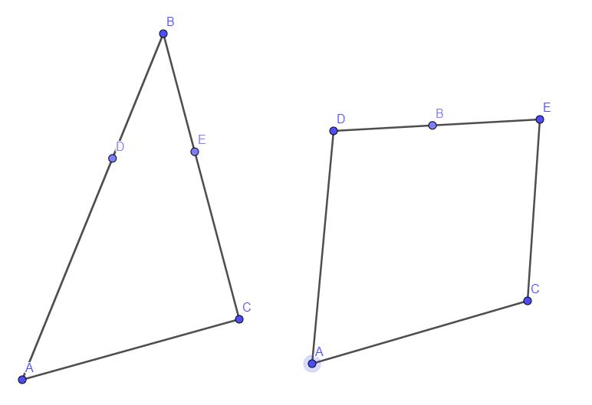
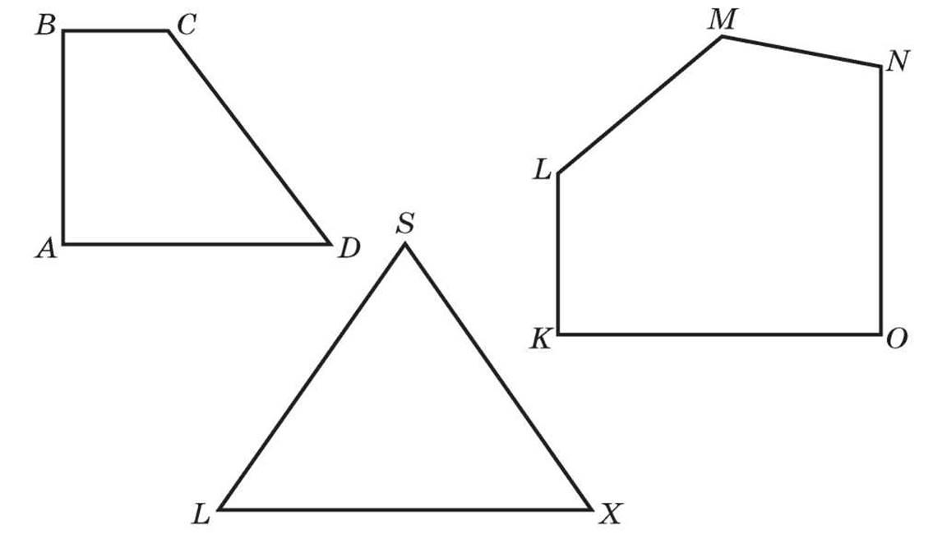
A Closed Polygonal Path is a sequence of connected line segments whose final vertex is the initial vertex.
$$\boxed{P_{0}=P_{n}}$$
It can be written as:
$$P=\overset{‾}{P_{0}P_{1}}∪\overset{‾}{P_{1}P_{2}}∪⋯∪\overset{‾}{P_{n-1}P_{n}}.$$
Example
$$A→B→C→D→A.$$
This forms a closed polygonal path.

6. Closed Piecewise-Linear Path
# Source: AI Source: Provided by: [Data Path: Persons Table -> ID Column: 1, Name_En Column: Motasem Essam] -> From: [ChatGPT] on [7/25/2026]
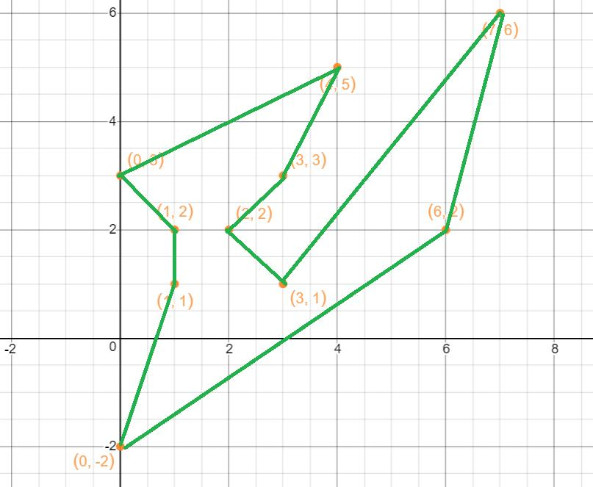
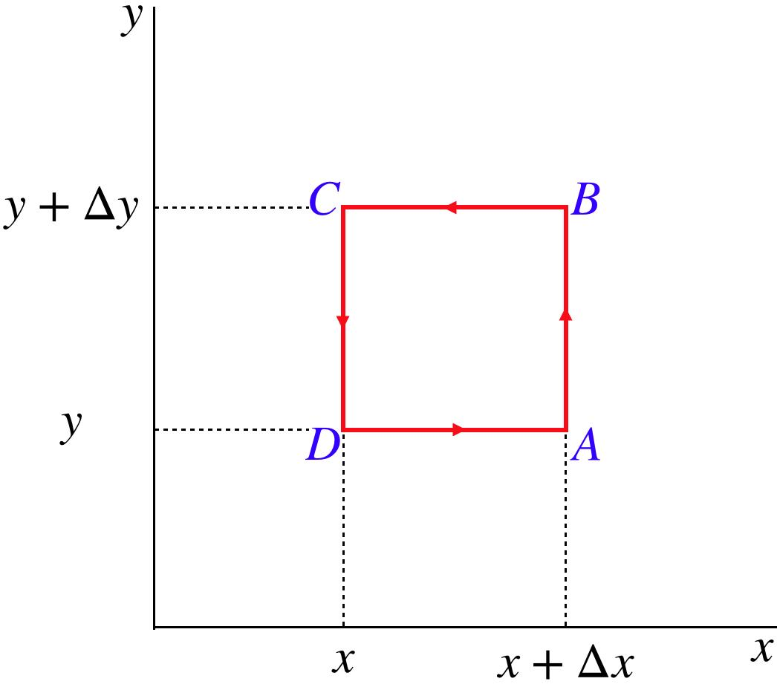
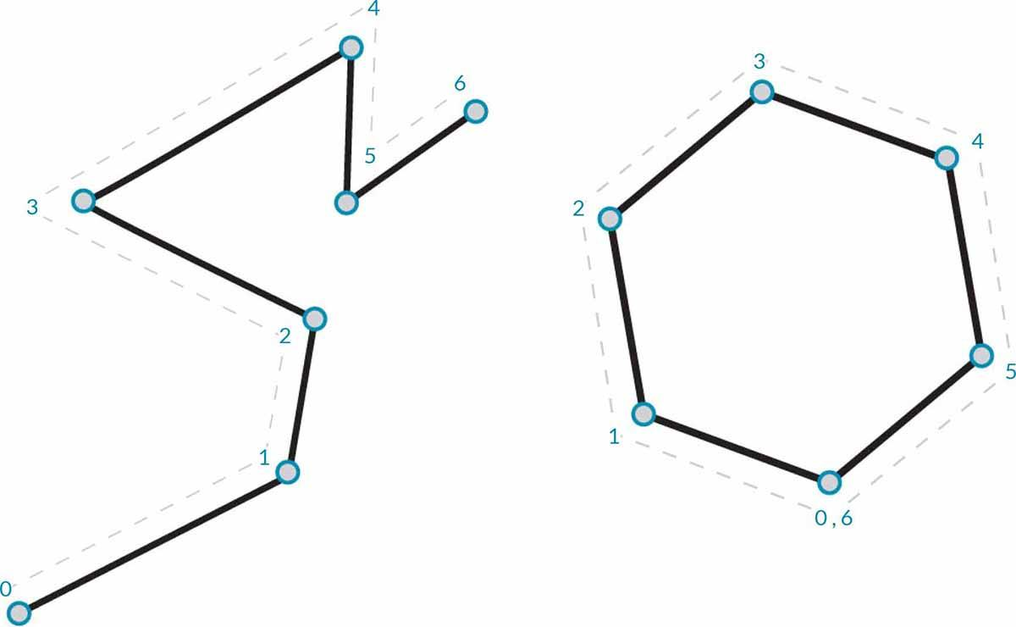
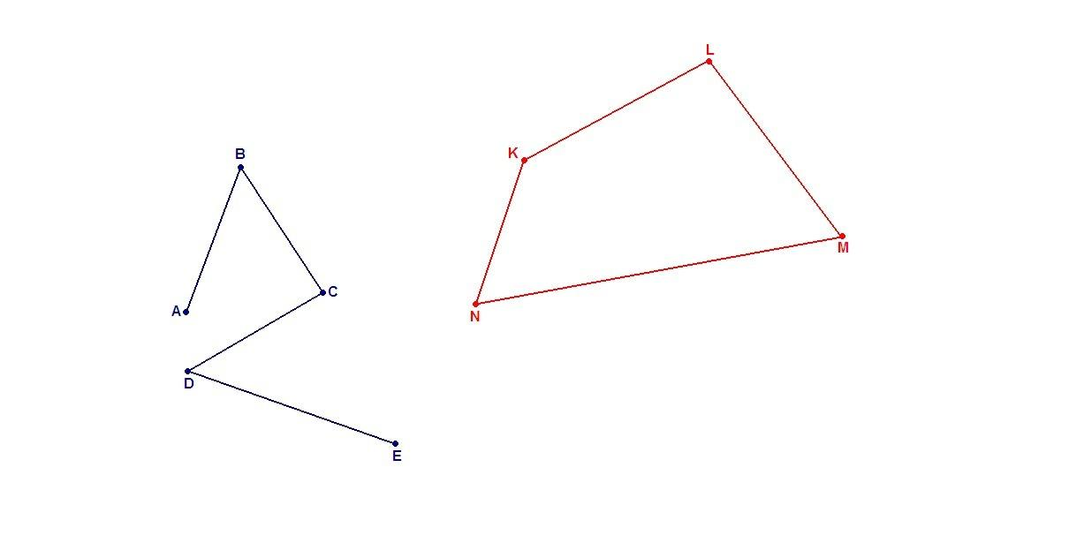
A Closed Piecewise-Linear Path consists of several straight-line pieces connected into a loop.
$$\boxed{P_{0}=P_{n}}$$
Example
$$A→B→C→D→A.$$
Every piece is linear, and the last piece returns to the starting point.
Thus:
$$\boxed{\text{Closed Polygonal Path}≈\text{Closed Piecewise-Linear Path}}$$

7. Closed Piecewise Path
# Source: AI Source: Provided by: [Data Path: Persons Table -> ID Column: 1, Name_En Column: Motasem Essam] -> From: [ChatGPT] on [7/25/2026]
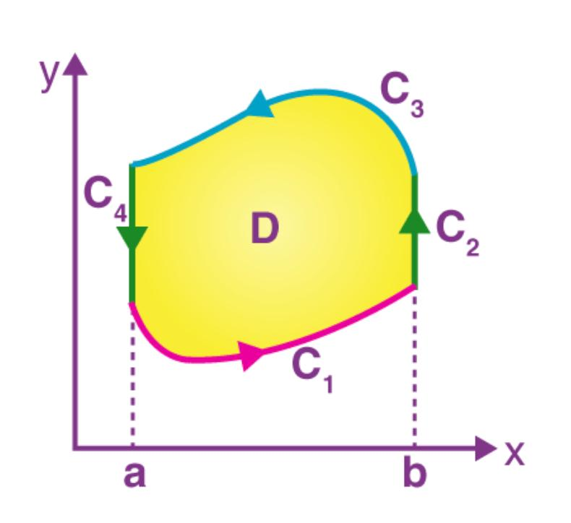
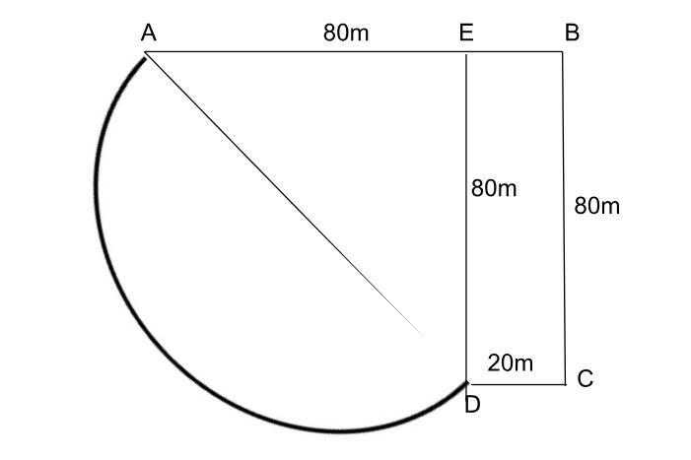
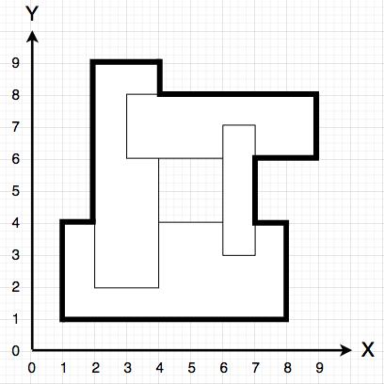
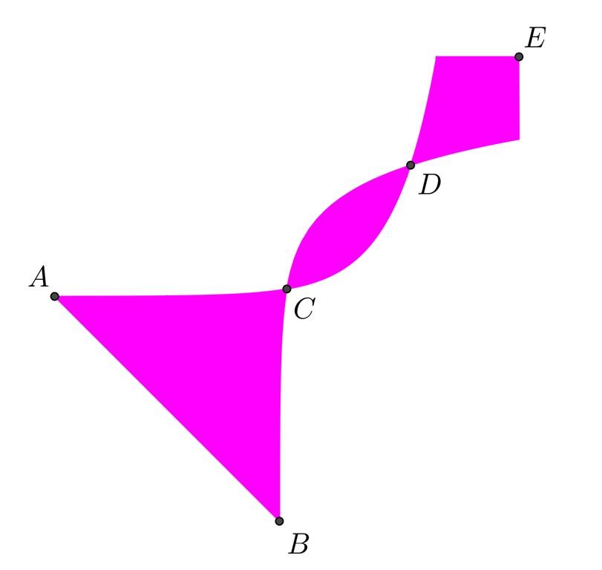
A Closed Piecewise Path consists of multiple pieces that collectively return to the starting point.
The pieces may be:
- straight segments,
- circular arcs,
- parabolic arcs,
- elliptical arcs,
- other curves.
Example
$$\boxed{\text{Line}→\text{Circular Arc}→\text{Line}→\text{Circular Arc}}$$
where the final piece returns to the initial point.

8. Closed Parametric Path
# Source: AI Source: Provided by: [Data Path: Persons Table -> ID Column: 1, Name_En Column: Motasem Essam] -> From: [ChatGPT] on [7/25/2026]
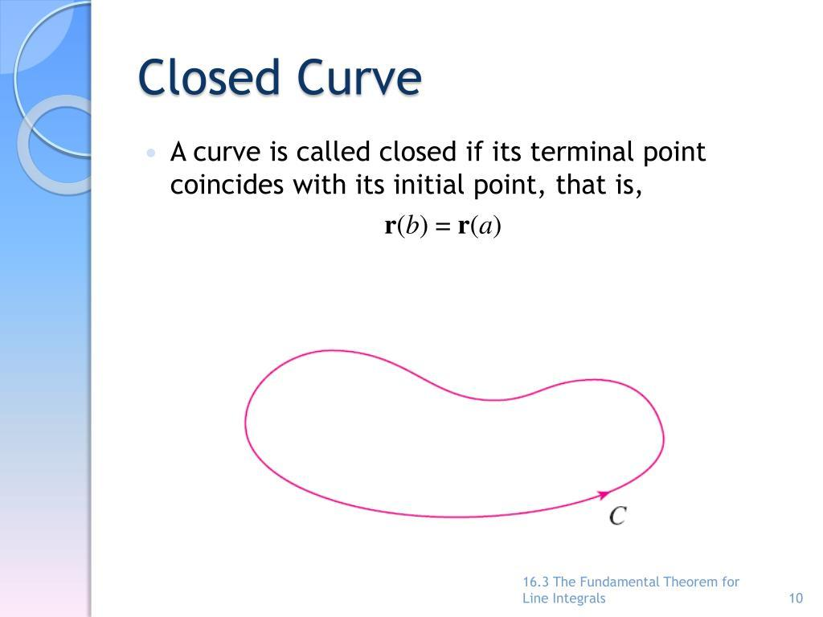
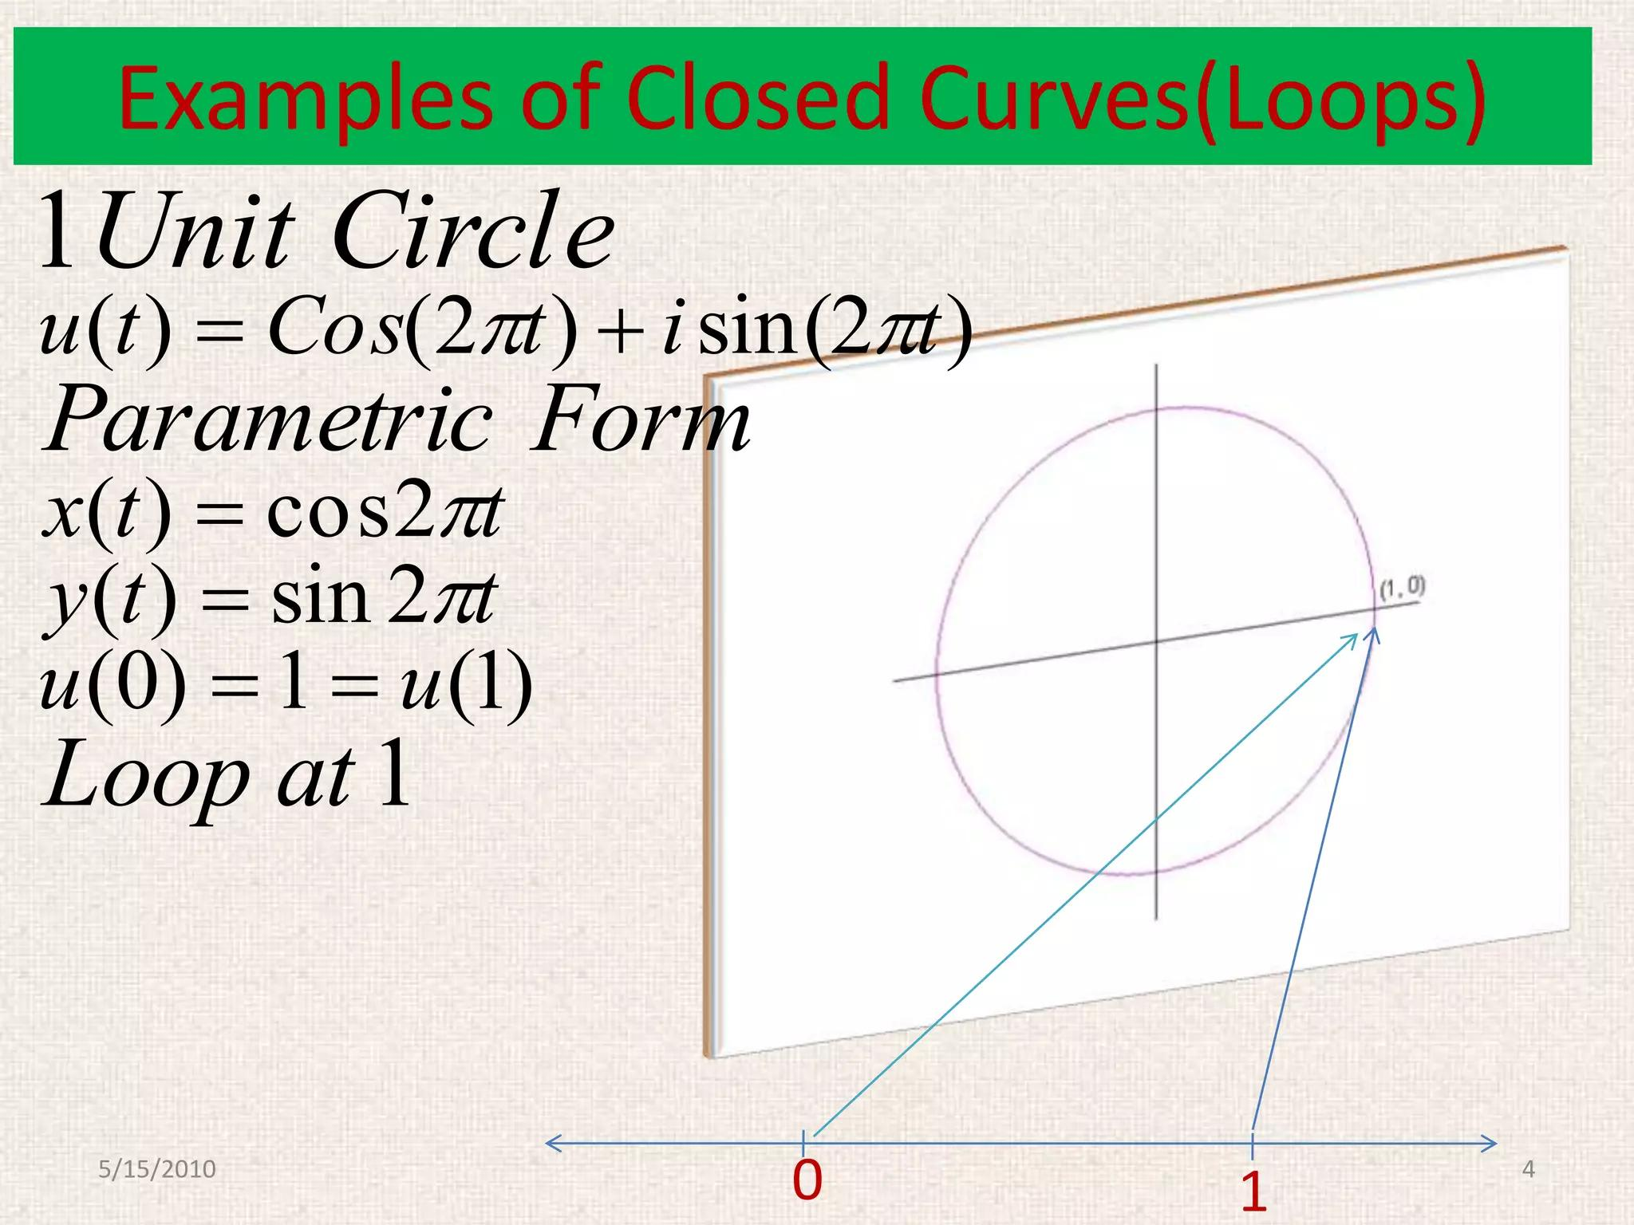
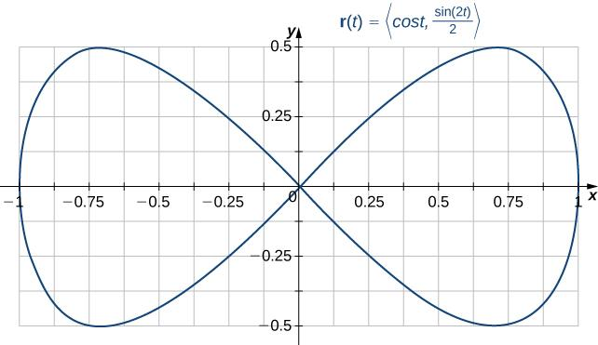
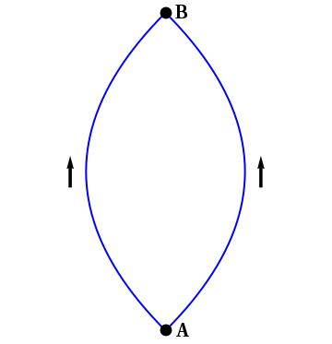
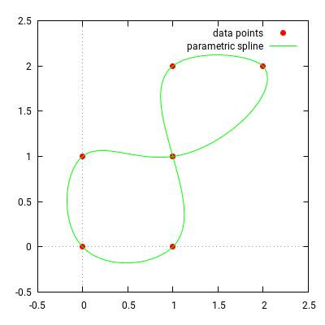
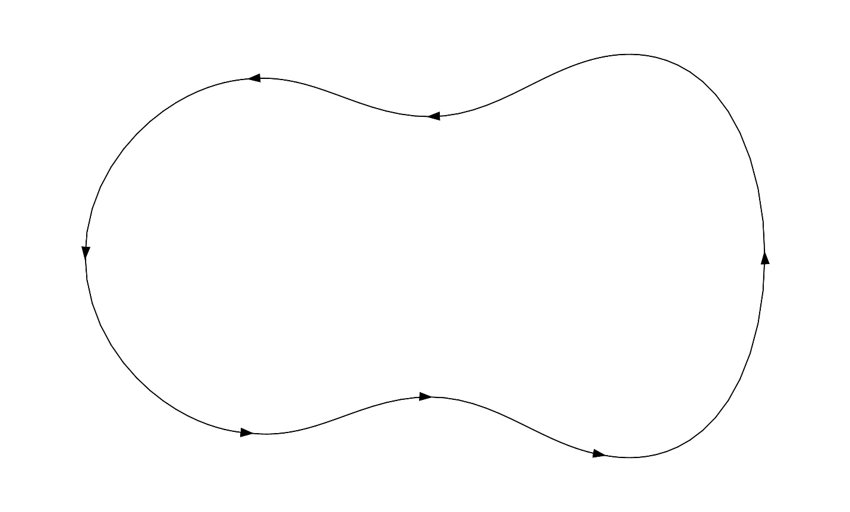
A Closed Parametric Path satisfies:
$$\boxed{r\left(a\right)=r\left(b\right)}.$$
Example
$$r\left(t\right)=\left\langle \cos{t} , \sin{t}\right\rangle , 0≤t≤2π.$$
Then:
$$r\left(0\right)=r\left(2π\right)=\left(1 , 0\right).$$
Therefore, the path is closed.

9. Closed Coordinate Path
# Source: AI Source: Provided by: [Data Path: Persons Table -> ID Column: 1, Name_En Column: Motasem Essam] -> From: [ChatGPT] on [7/25/2026]
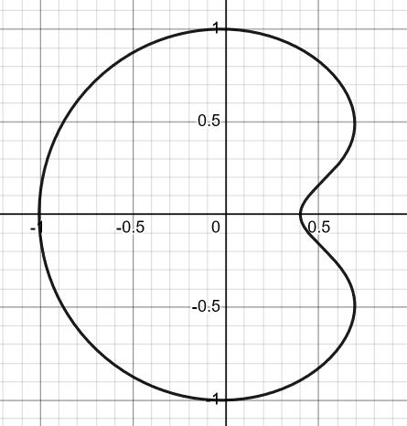
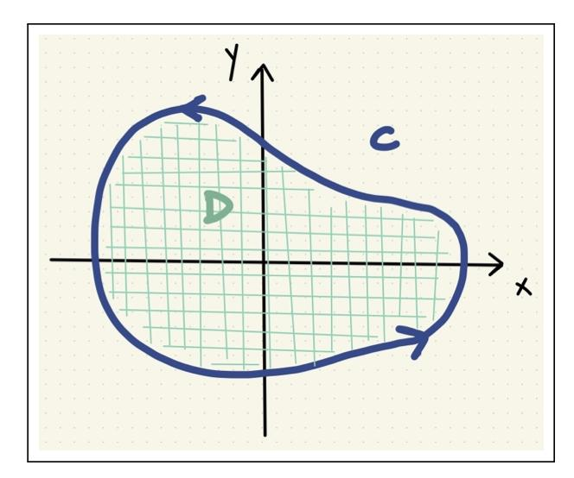
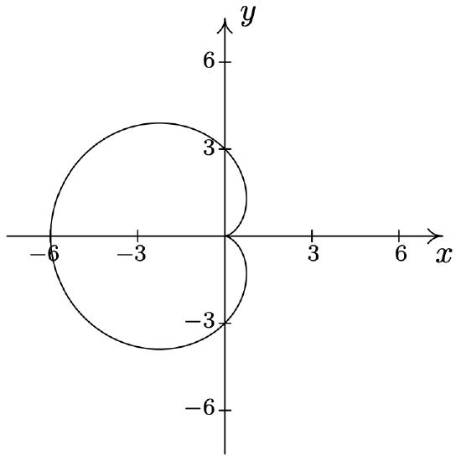
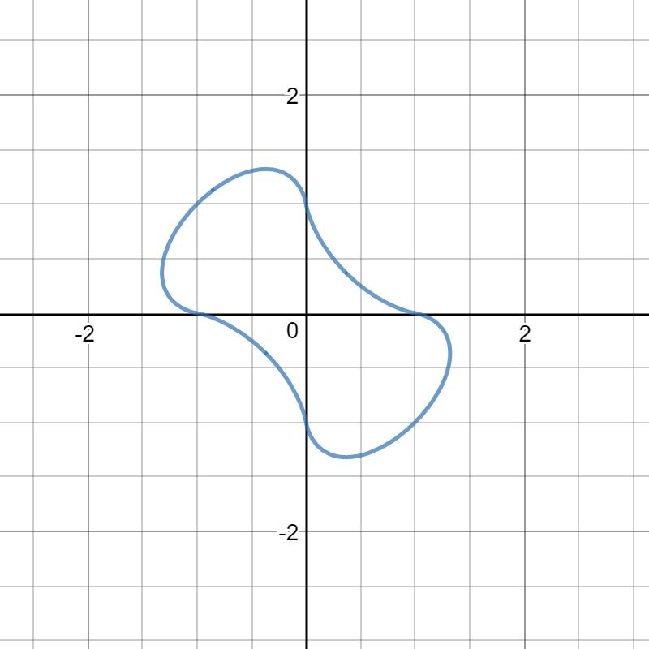
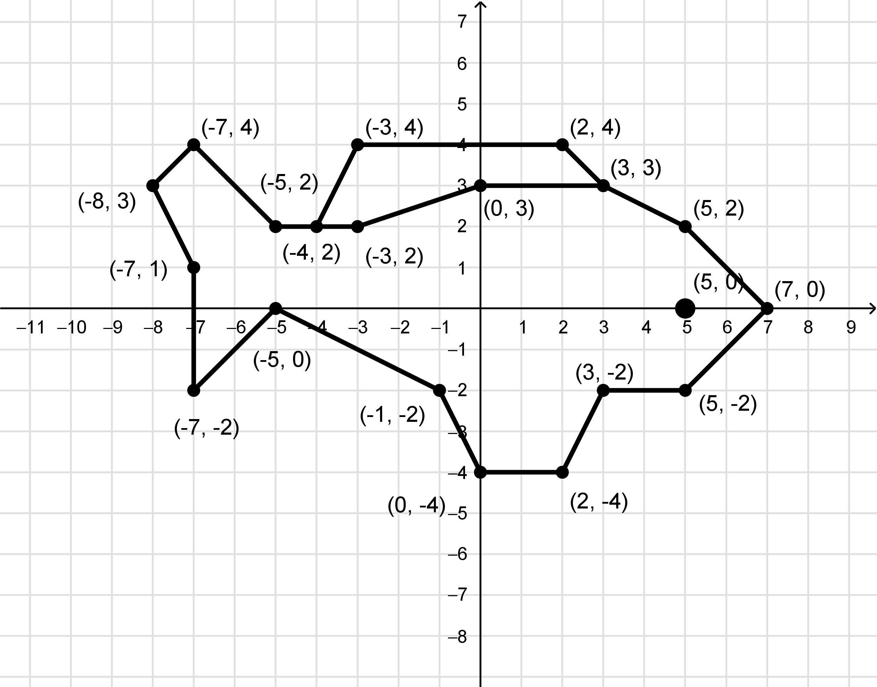
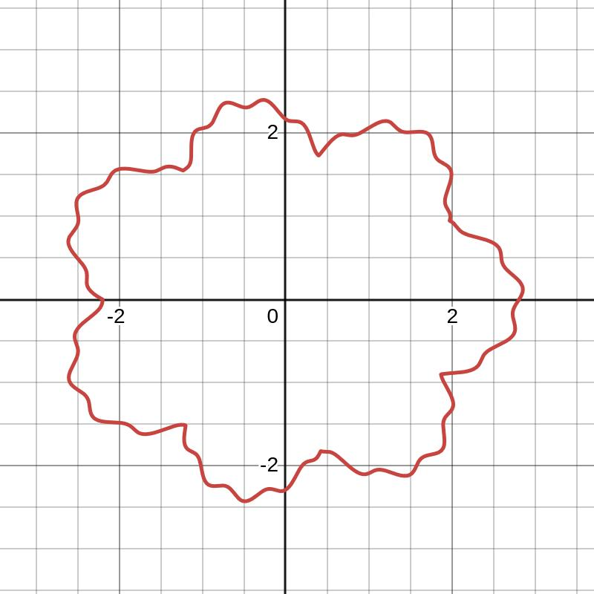
A Closed Coordinate Path is represented by a coordinate equation whose resulting path forms a closed curve.
Example
$$\boxed{x^{2}+y^{2}=25}$$
is a closed circular path.
Another example:
$$\boxed{\frac{x^{2}}{16}+\frac{y^{2}}{9}=1}$$
is a closed elliptical path.

10. Closed Vector-Defined Path
# Source: AI Source: Provided by: [Data Path: Persons Table -> ID Column: 1, Name_En Column: Motasem Essam] -> From: [ChatGPT] on [7/25/2026]
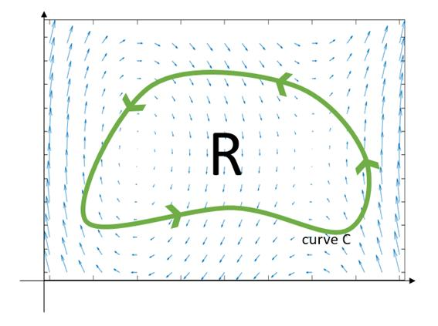
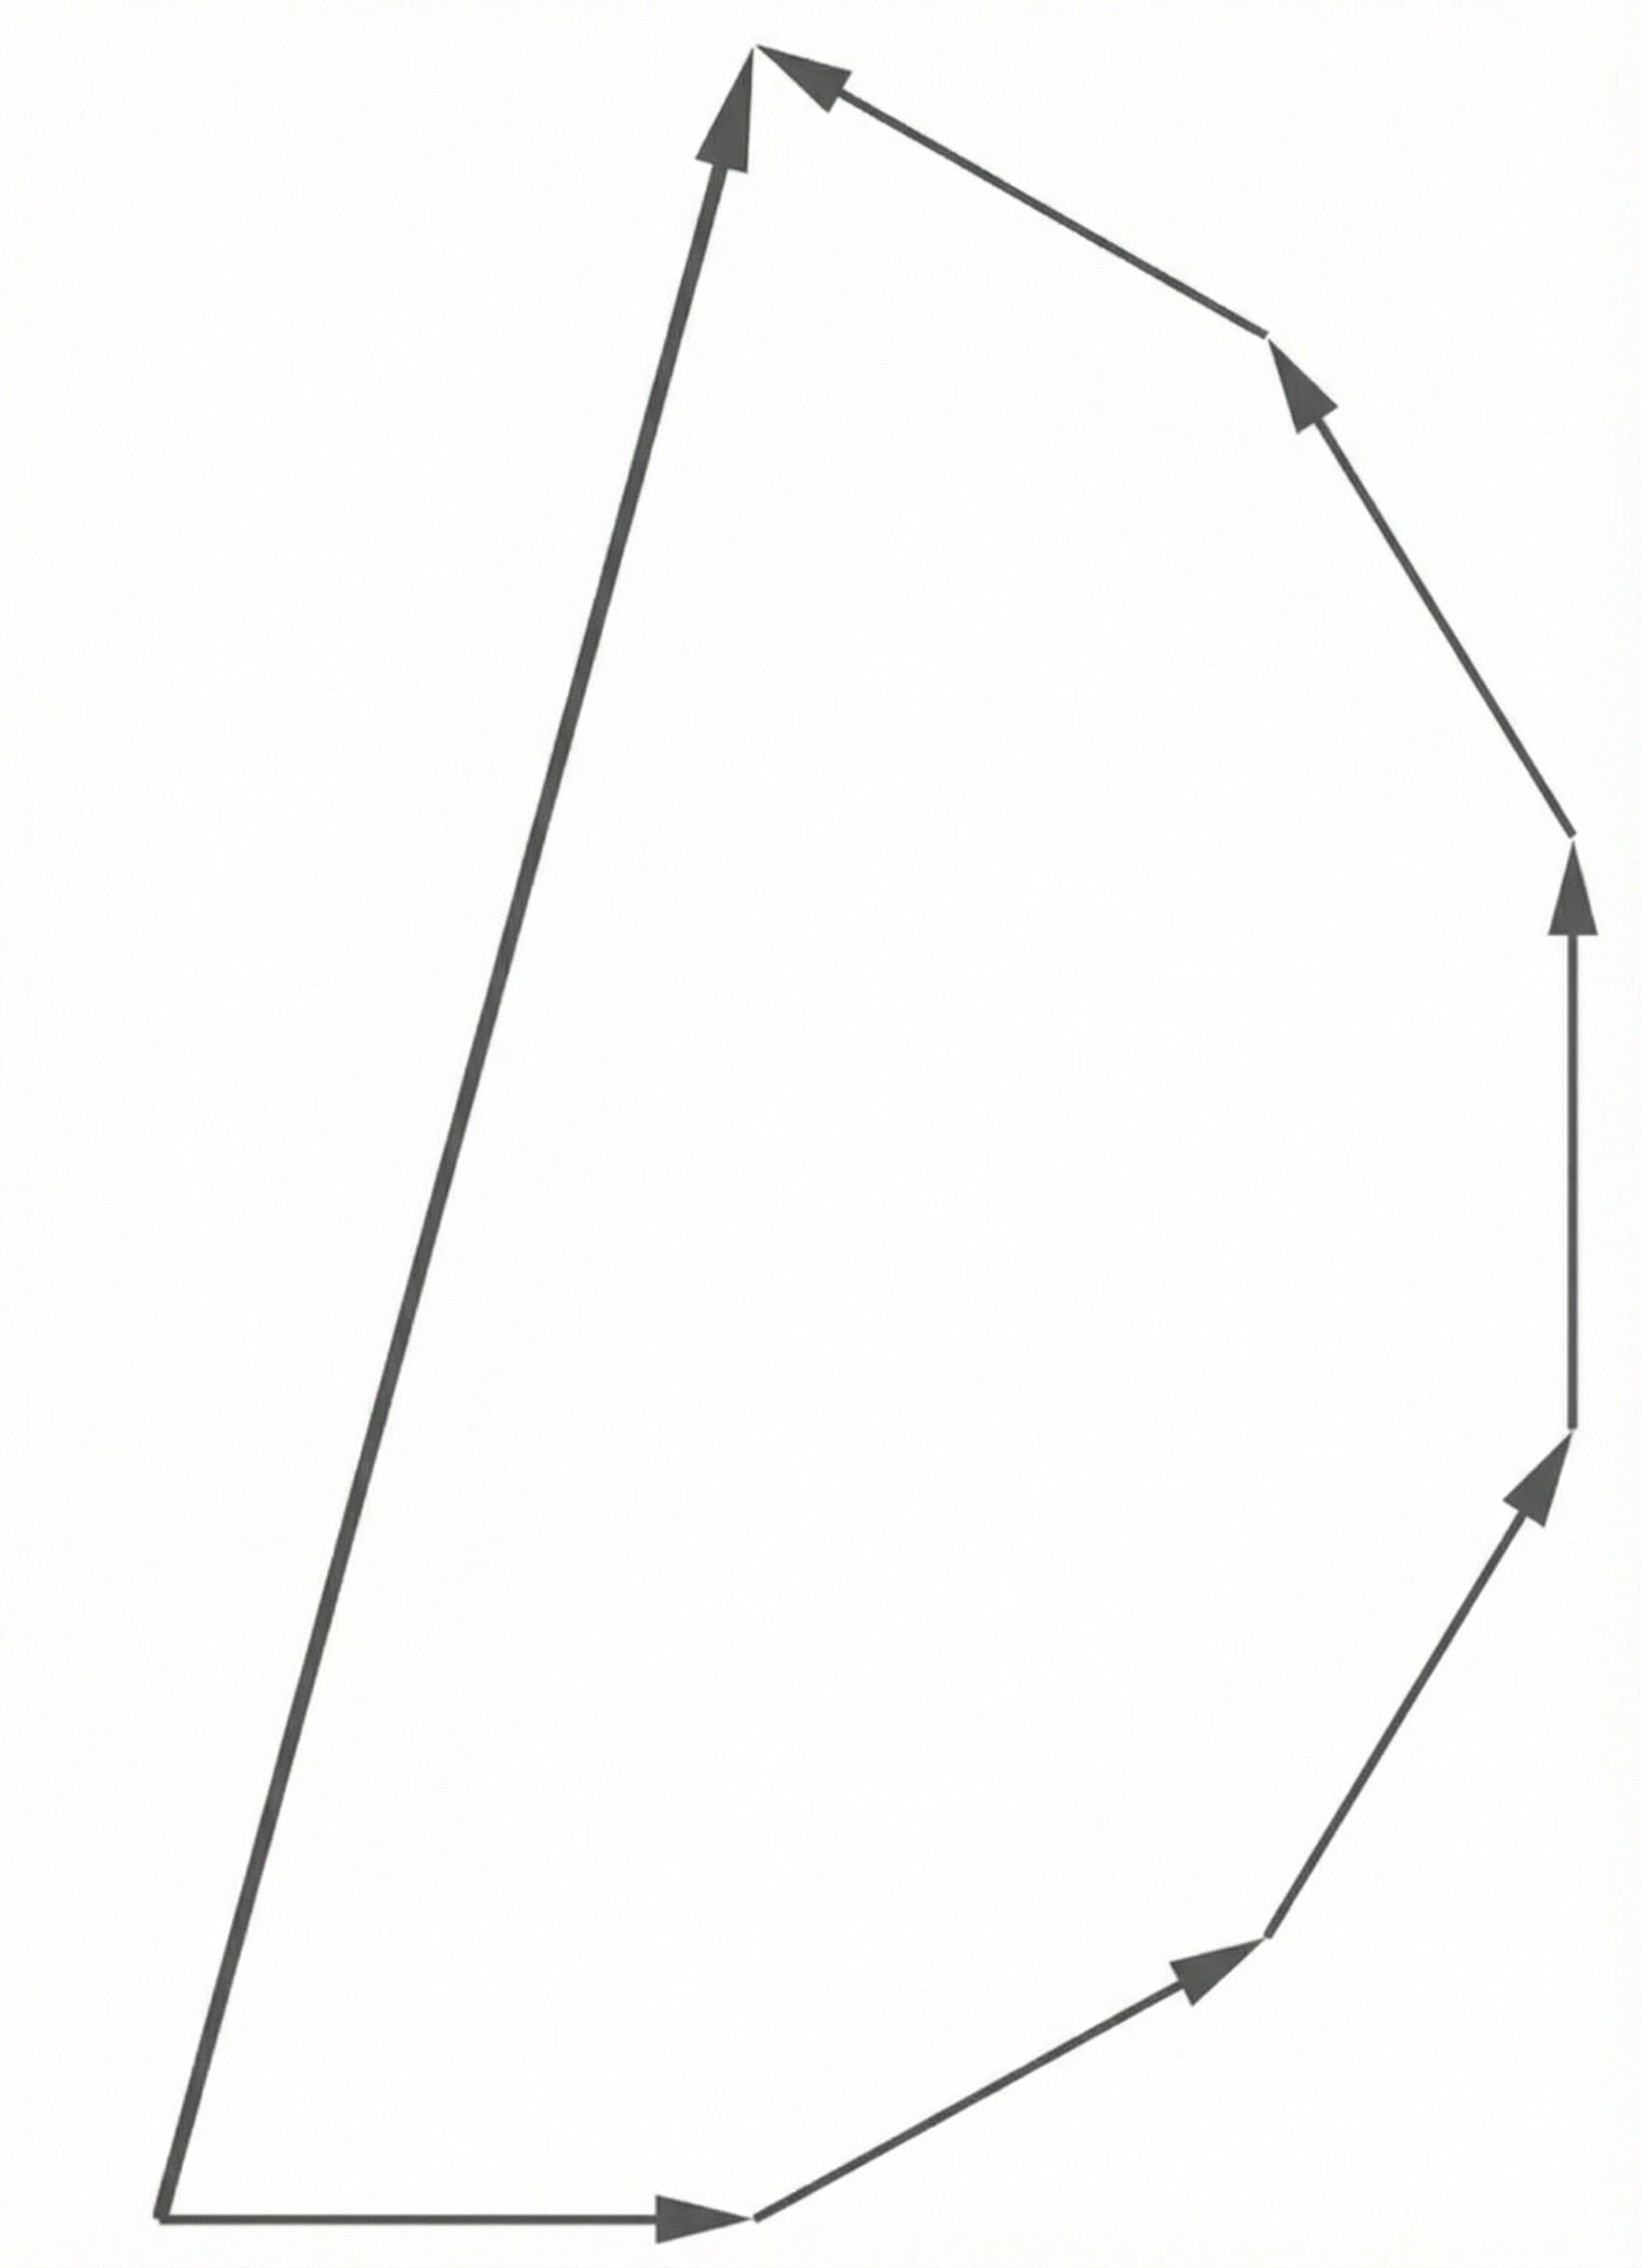
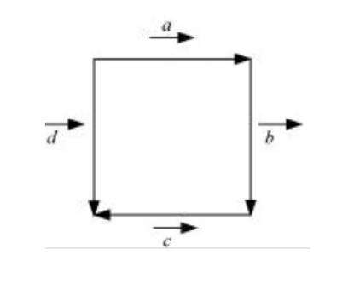
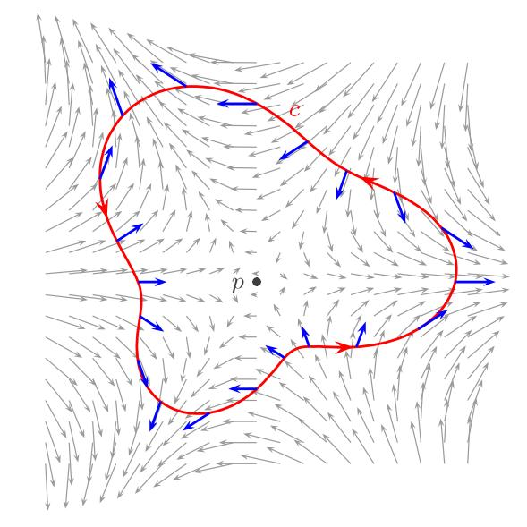
A Closed Vector-Defined Path is described by a vector-valued function satisfying:
$$\boxed{r\left(a\right)=r\left(b\right)}.$$
Example
$$r\left(t\right)=\left\langle 2 , \cos{t}2\sin{t}\right\rangle , 0≤t≤2π.$$
The point returns to its starting position.

11. Simple Closed Path
# Source: AI Source: Provided by: [Data Path: Persons Table -> ID Column: 1, Name_En Column: Motasem Essam] -> From: [ChatGPT] on [7/25/2026]
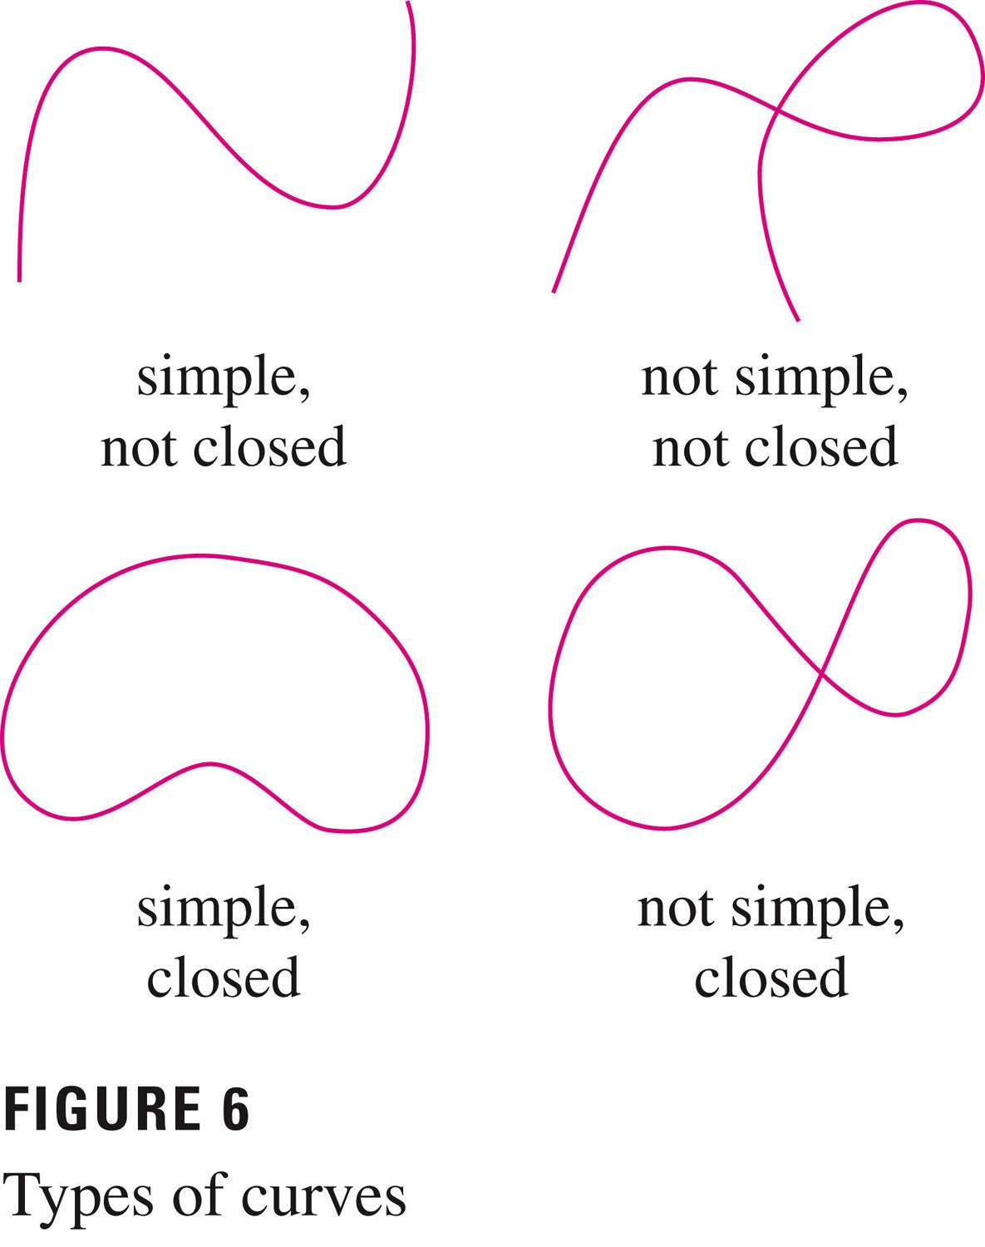
A Simple Closed Path is a closed path that does not intersect itself.
It satisfies:
$$\boxed{P_{\text{start}}=P_{\text{end}}}$$
and has no other self-intersections.
Examples
- circle
- ellipse
- simple polygon
- square boundary
A simple closed curve is closely related to the setting of the Jordan curve theorem.

12. Self-Intersecting Closed Path
# Source: AI Source: Provided by: [Data Path: Persons Table -> ID Column: 1, Name_En Column: Motasem Essam] -> From: [ChatGPT] on [7/25/2026]
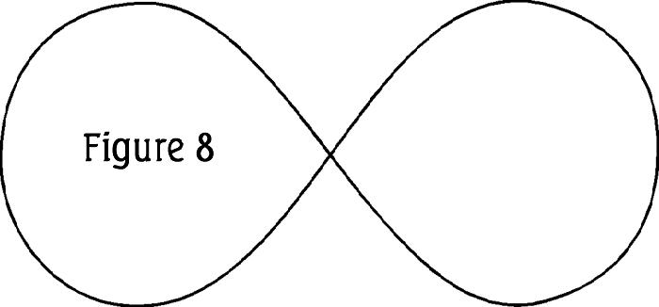
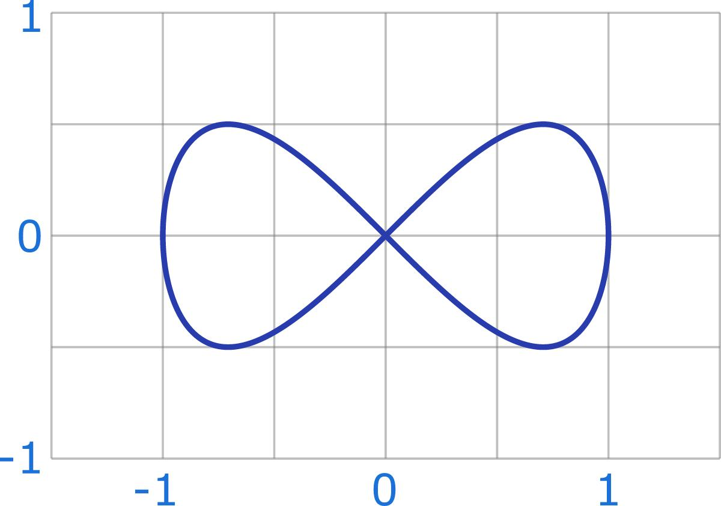
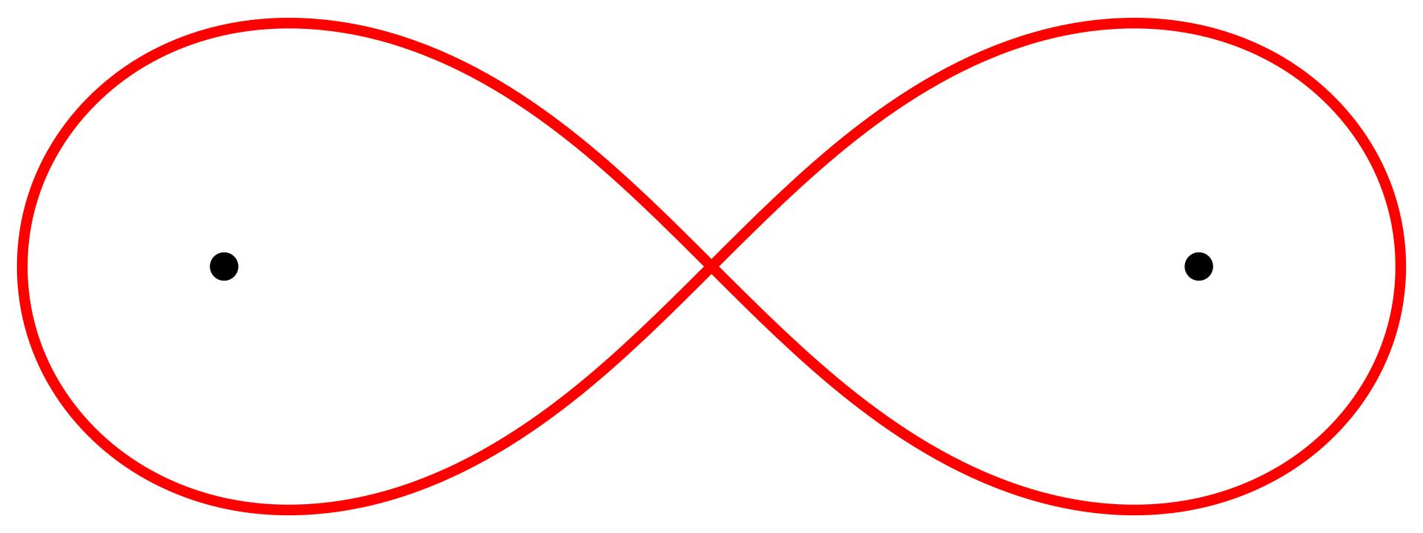
A Self-Intersecting Closed Path returns to its starting point but also intersects itself elsewhere.
Example
A figure-eight-shaped closed path can satisfy:
$$r\left(a\right)=r\left(b\right)$$
while also having
$$r\left(t_{1}\right)=r\left(t_{2}\right), t_{1}≠t_{2},$$
for another pair of parameter values.
Important Point
Closed does not necessarily mean simple.

13. Smooth Closed Path
# Source: AI Source: Provided by: [Data Path: Persons Table -> ID Column: 1, Name_En Column: Motasem Essam] -> From: [ChatGPT] on [7/25/2026]
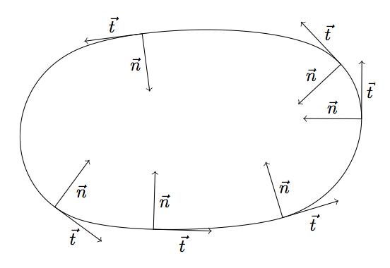
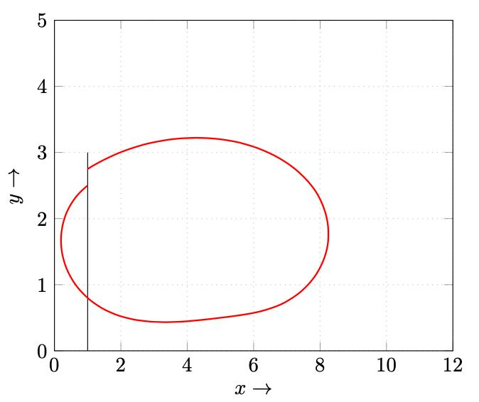
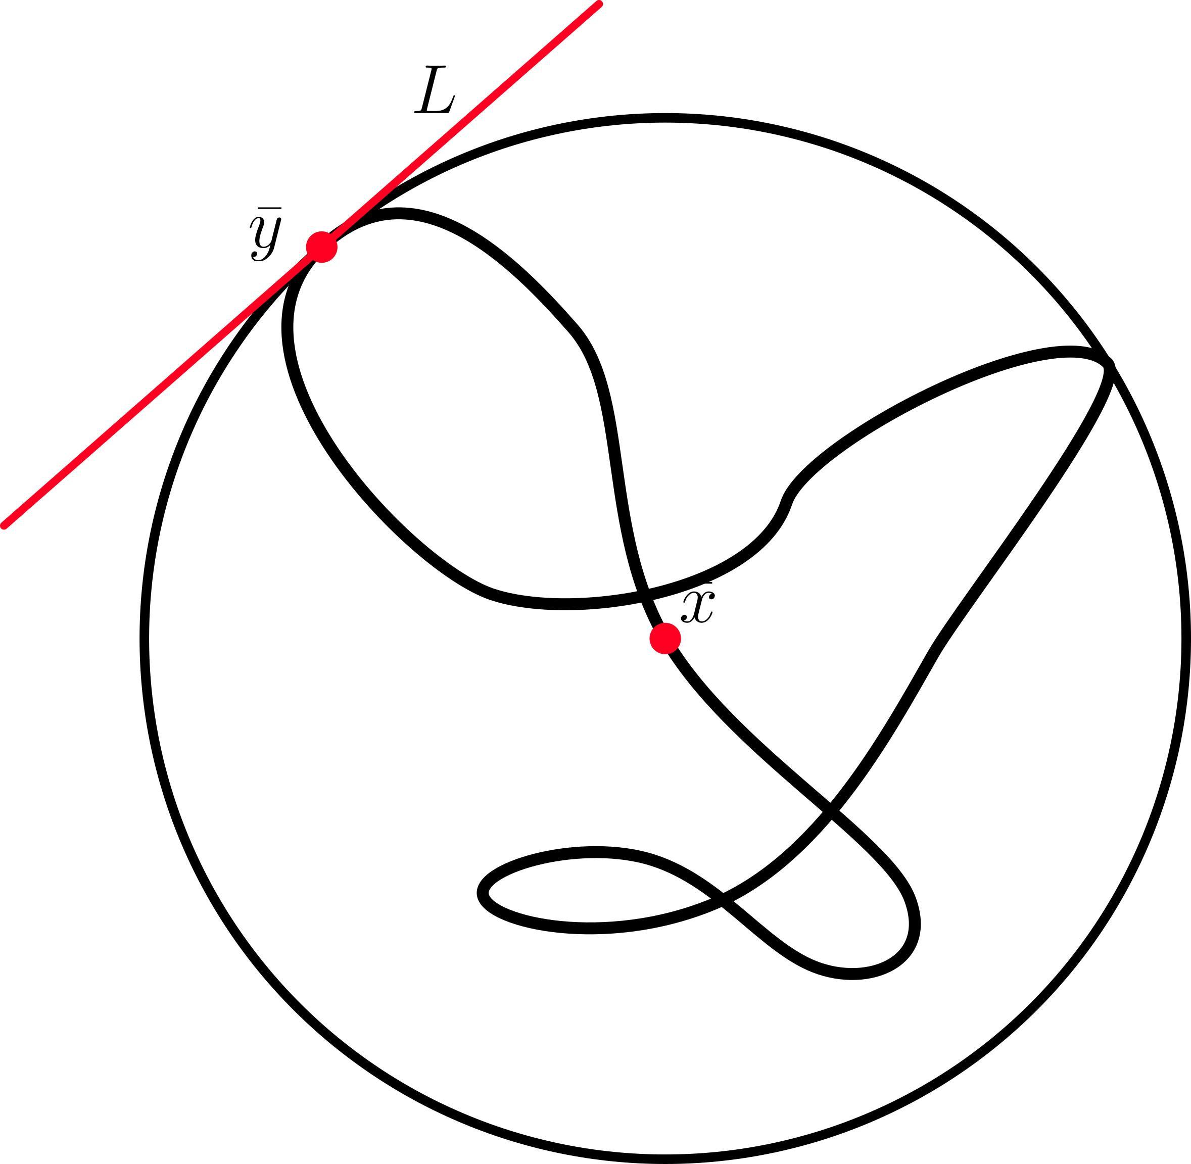
A Smooth Closed Path is a closed path whose tangent direction changes continuously around the path.
Example
A circle is a smooth closed path.
Its tangent exists continuously at every point.
Important Property
The path satisfies both:
$$\boxed{r\left(a\right)=r\left(b\right)}$$
and appropriate smoothness conditions.

14. Non-Smooth Closed Path
# Source: AI Source: Provided by: [Data Path: Persons Table -> ID Column: 1, Name_En Column: Motasem Essam] -> From: [ChatGPT] on [7/25/2026]
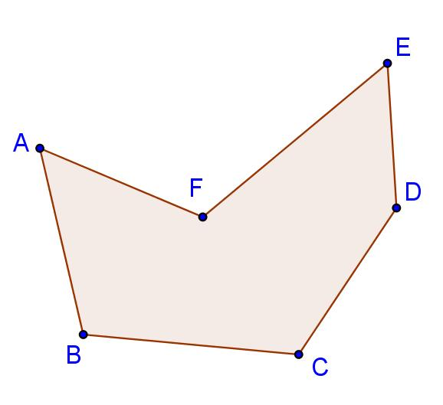
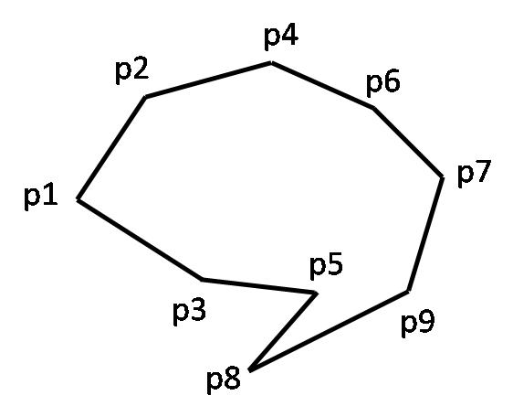
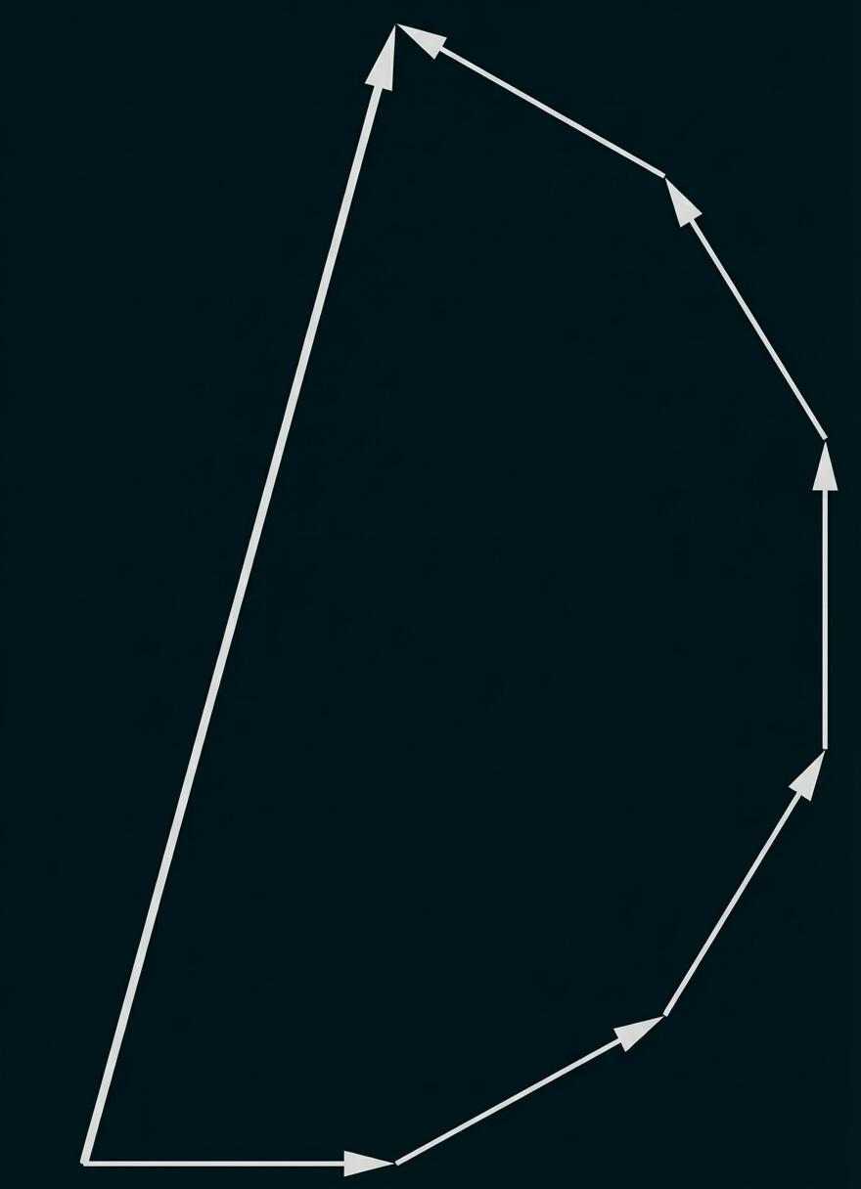
A Non-Smooth Closed Path returns to its starting point but contains sharp corners or other non-smooth points.
Example
A square boundary:
$$A→B→C→D→A$$
is closed but has four corners.
At each corner, the incoming and outgoing tangent directions differ.
Thus:
$$\boxed{\text{Closed}⇏\text{Smooth}}.$$

15. Convex Closed Path
# Source: AI Source: Provided by: [Data Path: Persons Table -> ID Column: 1, Name_En Column: Motasem Essam] -> From: [ChatGPT] on [7/25/2026]
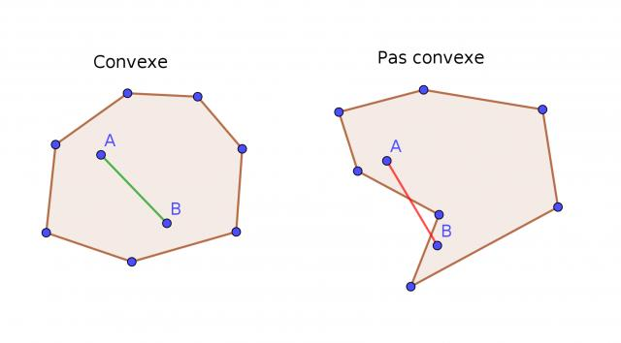
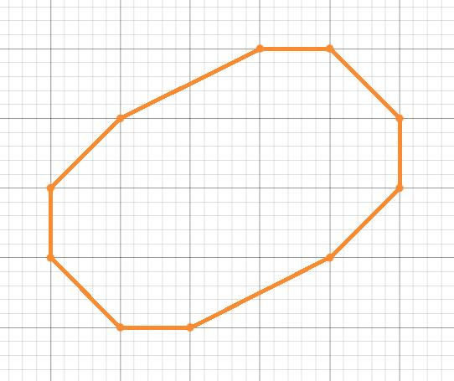
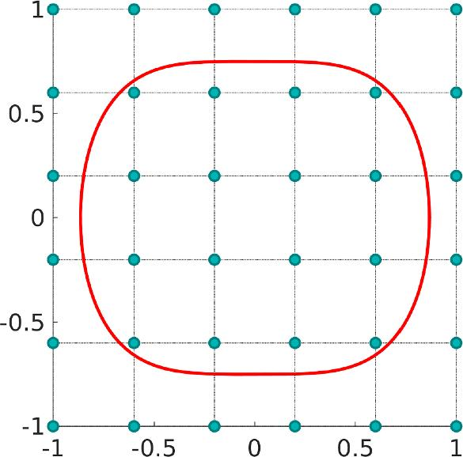
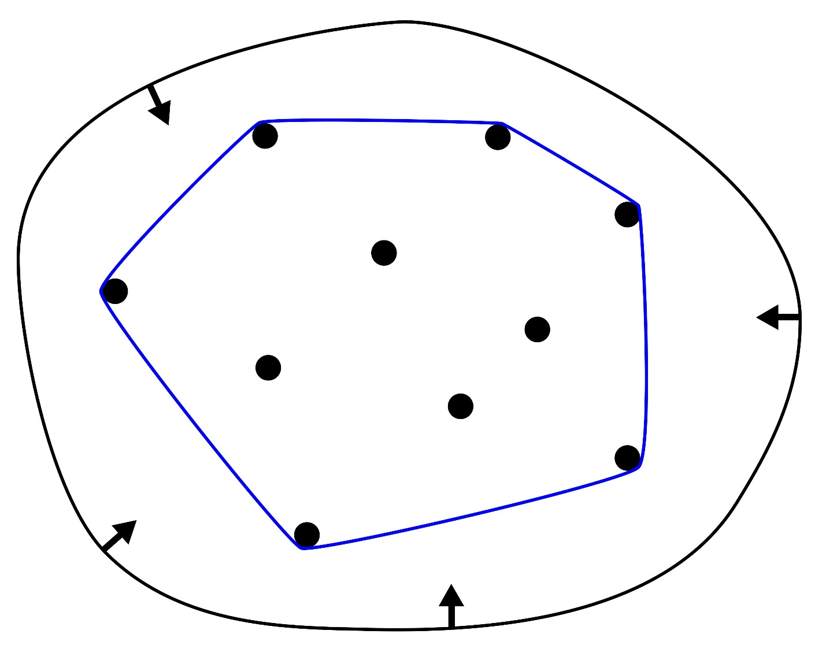
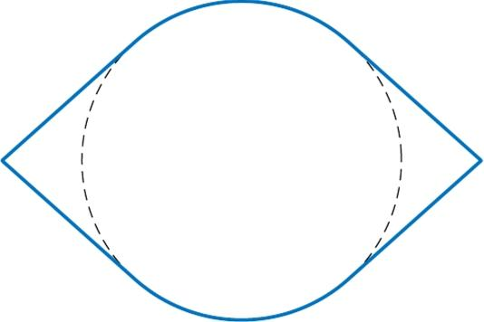
A Convex Closed Path is the boundary of a convex region, in the usual planar setting.
For any two points $A$and $B$on the boundary, the line segment connecting them lies entirely within the enclosed region.
Examples
- circle
- ellipse
- square
- rectangle
- regular convex polygon
Example
A circle is a convex closed path because its enclosed disk is convex.

16. Concave Closed Path
# Source: AI Source: Provided by: [Data Path: Persons Table -> ID Column: 1, Name_En Column: Motasem Essam] -> From: [ChatGPT] on [7/25/2026]
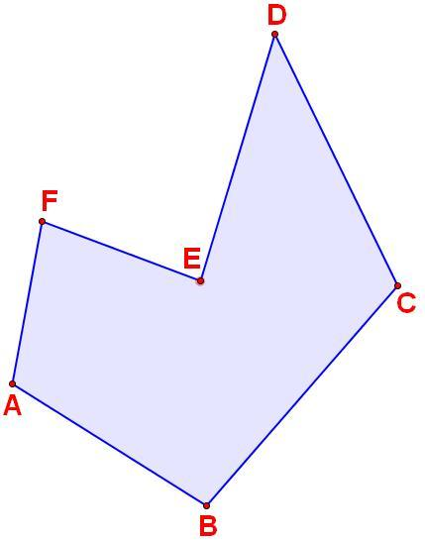
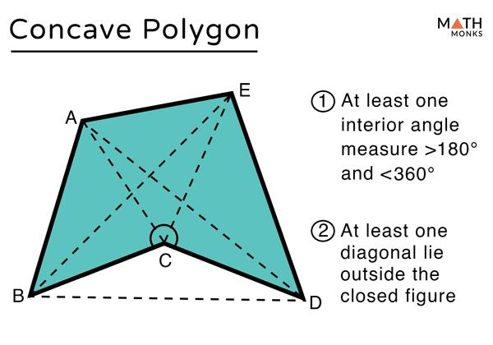
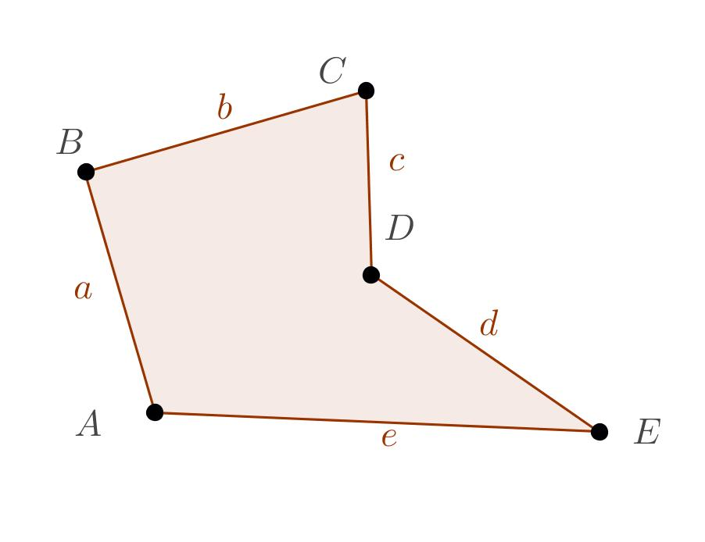
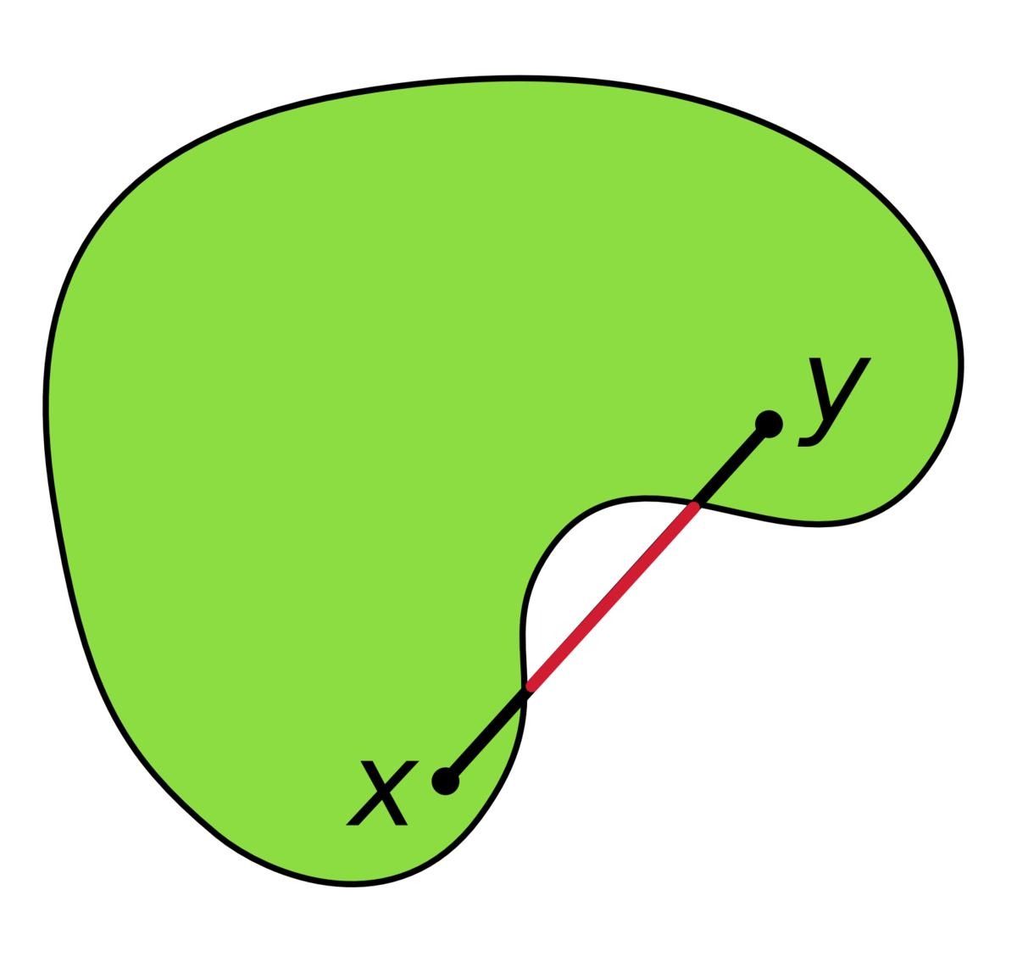
A Concave Closed Path encloses a region that is not convex.
Example
A concave polygon such as an arrow-shaped polygon forms a concave closed path.
A line segment connecting two points inside the enclosed region can leave the region.
Important Point
Concavity is a property of the enclosed geometry, while closedness is determined by the endpoints.

17. Restricted Closed Path
# Source: AI Source: Provided by: [Data Path: Persons Table -> ID Column: 1, Name_En Column: Motasem Essam] -> From: [ChatGPT] on [7/25/2026]
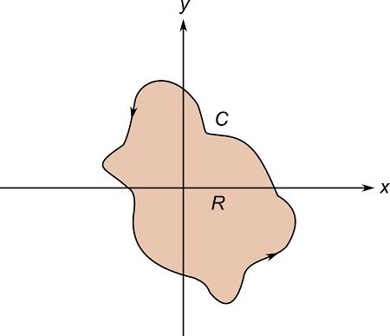
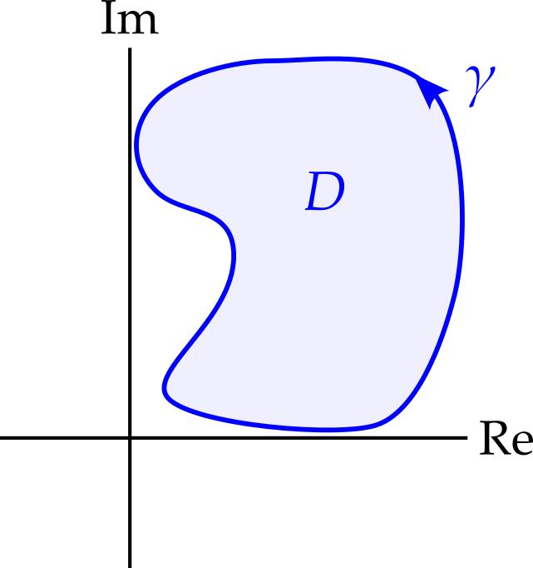
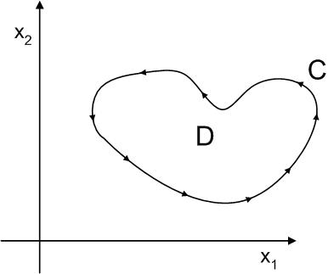
A Restricted Closed Path is a closed path subject to additional constraints.
For example, a curve may be required to remain inside a region:
$$P\left(t\right)∈R.$$
Example
A circular path
$$x^{2}+y^{2}=25$$
restricted to a particular allowed region may remain closed if the entire loop satisfies the restriction.

18. Periodic Closed Path
# Source: AI Source: Provided by: [Data Path: Persons Table -> ID Column: 1, Name_En Column: Motasem Essam] -> From: [ChatGPT] on [7/25/2026]
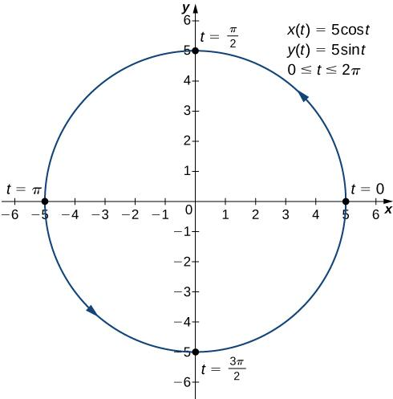
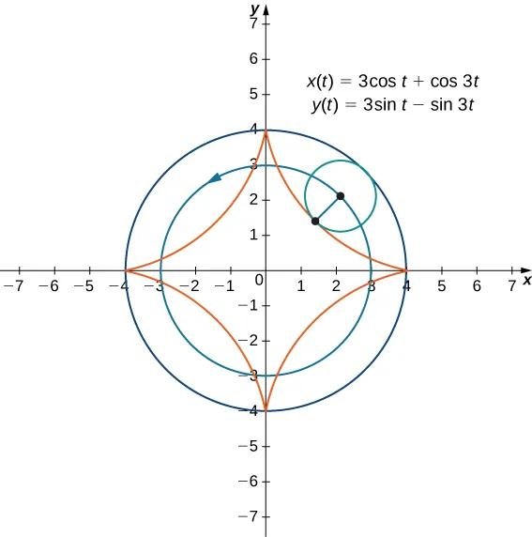
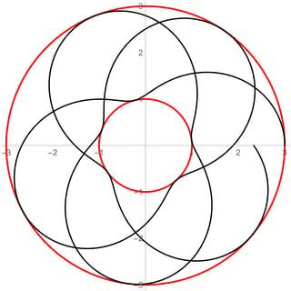
A Periodic Closed Path is represented by a parameterization that repeats after a fixed parameter interval.
There exists a positive period $T$such that:
$$\boxed{r\left(t+T\right)=r\left(t\right)}$$
for all relevant $t$.
Example
For a circle:
$$r\left(t\right)=\left\langle \cos{t} , \sin{t}\right\rangle$$
has period
$$\boxed{T=2π}.$$
Important Distinction
A closed path can be parameterized periodically, but the geometric path itself does not require a particular parameterization.

19. Multiple-Loop Closed Path
# Source: AI Source: Provided by: [Data Path: Persons Table -> ID Column: 1, Name_En Column: Motasem Essam] -> From: [ChatGPT] on [7/25/2026]
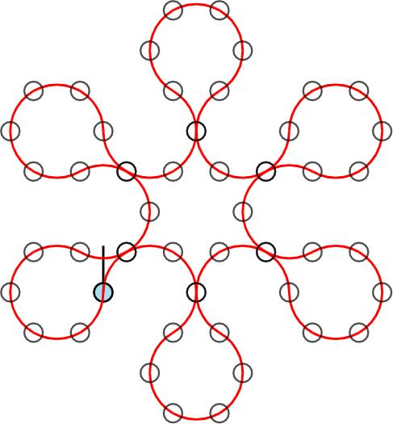
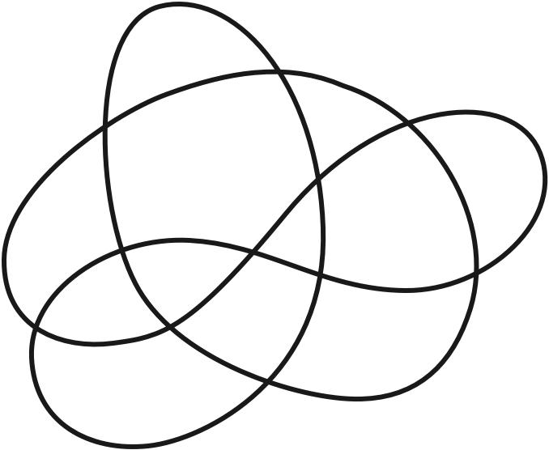
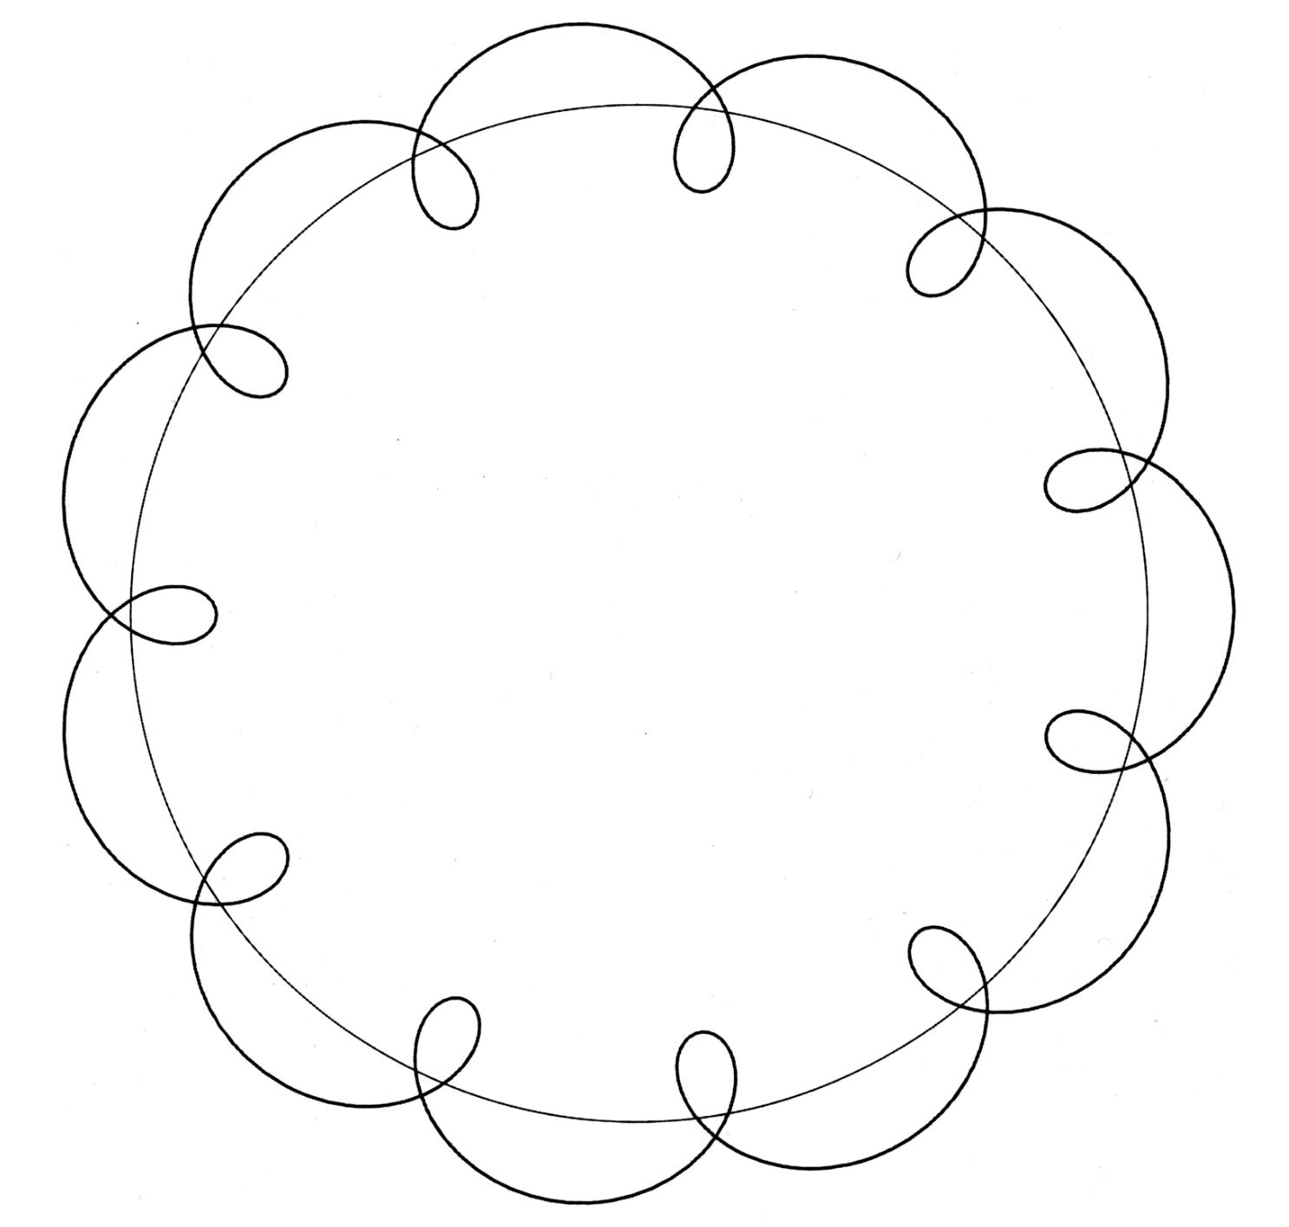
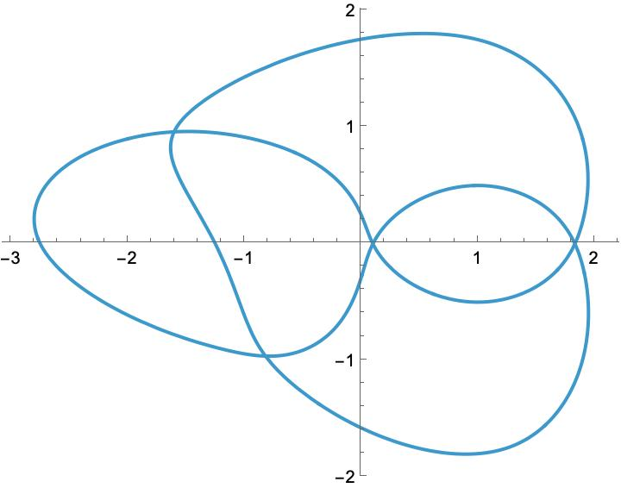
A Multiple-Loop Closed Path returns to its starting point while making multiple loops or revolutions.
Example
A parameterized circular path traversed twice can be written as:
$$x=\cos{t}, y=\sin{t},$$
with
$$0≤t≤4π.$$
The geometric path is still the same circle, but the traversal makes two complete revolutions.
Important Distinction
Geometric path and traversal are not always the same concept.
The same geometric path can be traversed multiple times.

20. Combined Closed Path
# Source: AI Source: Provided by: [Data Path: Persons Table -> ID Column: 1, Name_En Column: Motasem Essam] -> From: [ChatGPT] on [7/25/2026]
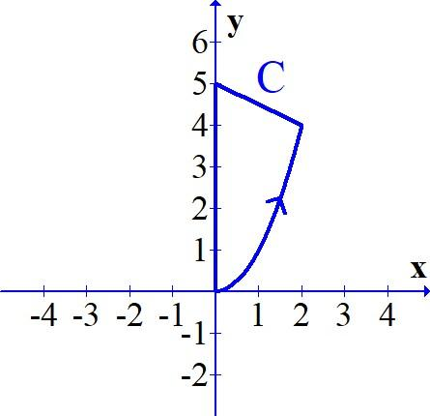
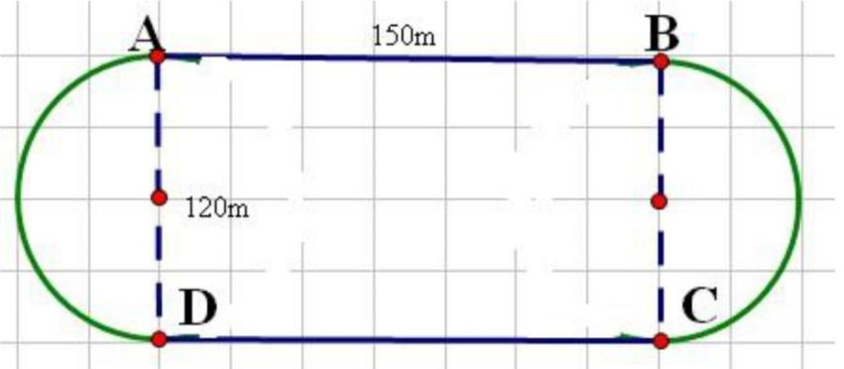
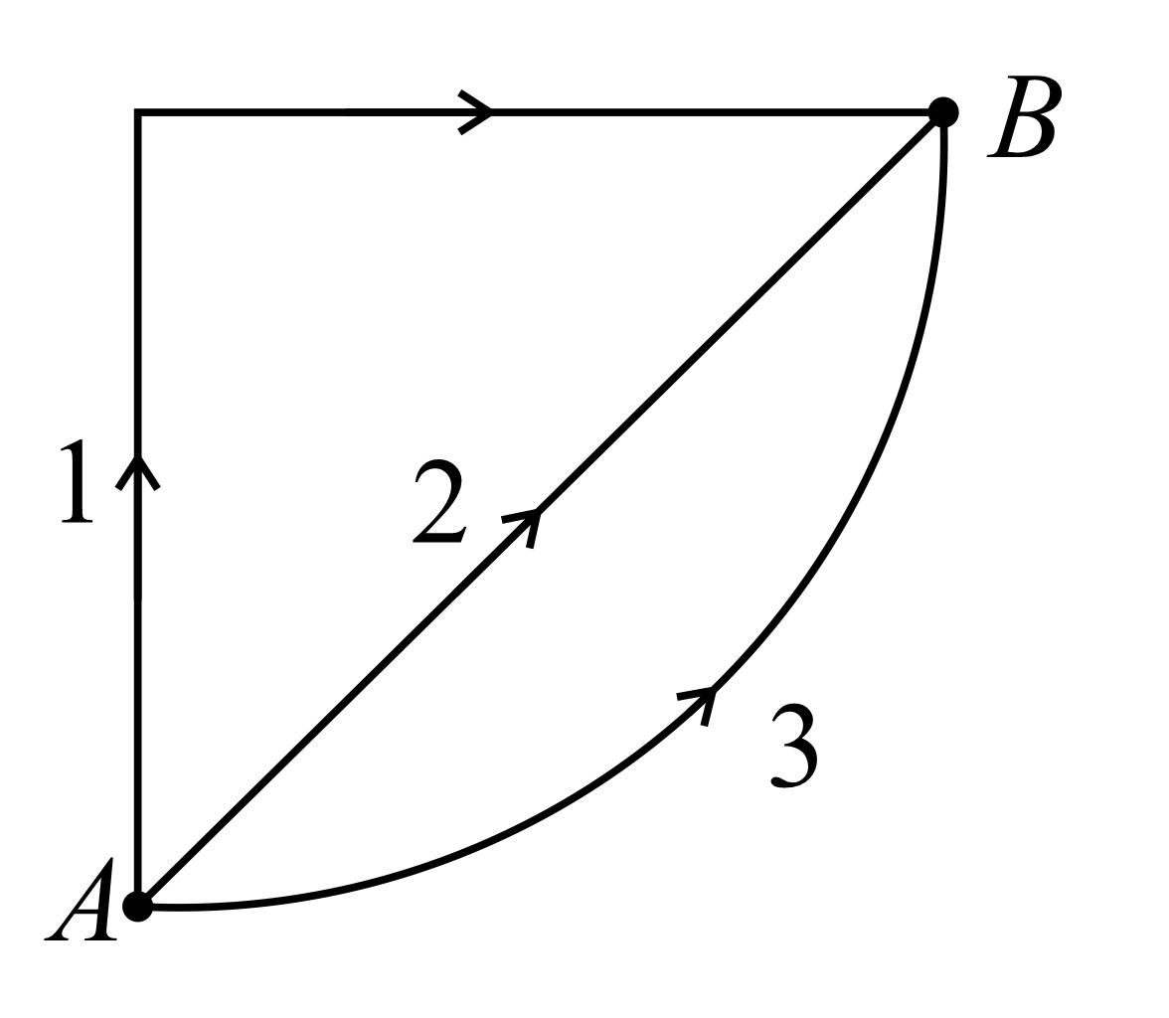
A Combined Closed Path contains different types of pieces and ultimately returns to its starting point.
For example:
$$\boxed{\text{Straight}→\text{Circular Arc}→\text{Parabolic Arc}→\text{Straight}→\text{Starting Point}}$$
The pieces may have different geometric properties, but collectively they form one closed path.

Fundamental Condition for a Closed Path
# Source: AI Source: Provided by: [Data Path: Persons Table -> ID Column: 1, Name_En Column: Motasem Essam] -> From: [ChatGPT] on [7/25/2026]
The defining condition is:
$$\boxed{P_{\text{start}}=P_{\text{end}}}$$
For a parameterized path:
$$\boxed{r\left(a\right)=r\left(b\right)}$$
For a polygonal path:
$$\boxed{P_{0}=P_{n}}$$
This is the fundamental distinction between closed and open paths.

Open Path vs Closed Path
# Source: AI Source: Provided by: [Data Path: Persons Table -> ID Column: 1, Name_En Column: Motasem Essam] -> From: [ChatGPT] on [7/25/2026]
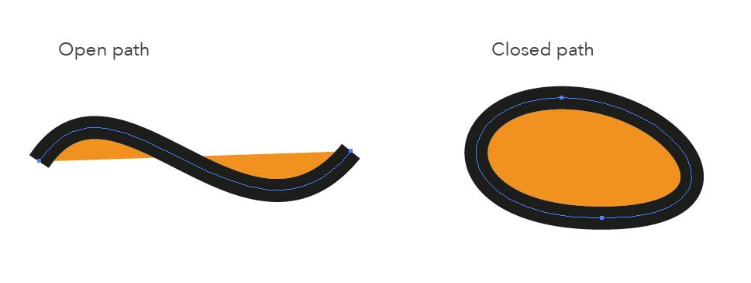
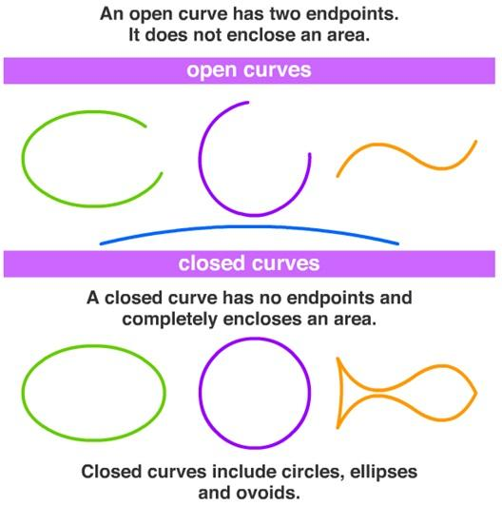
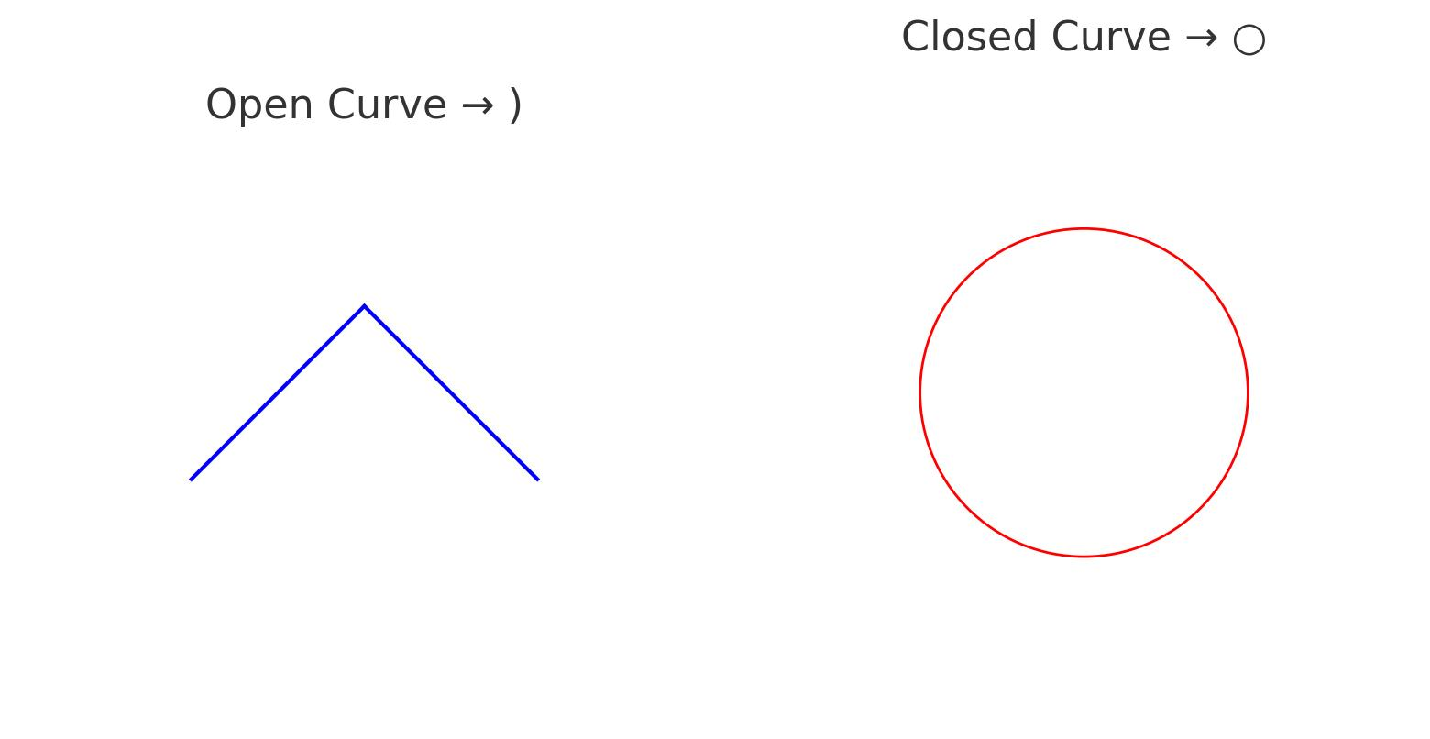
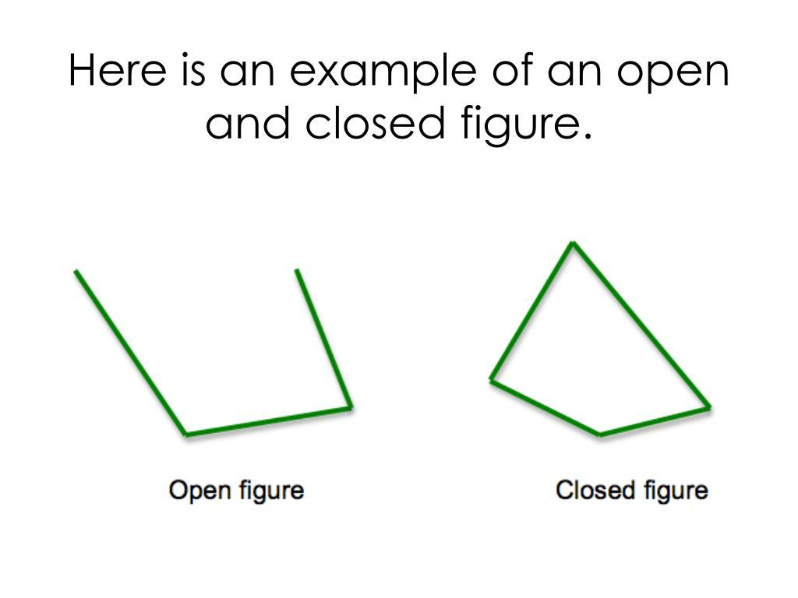
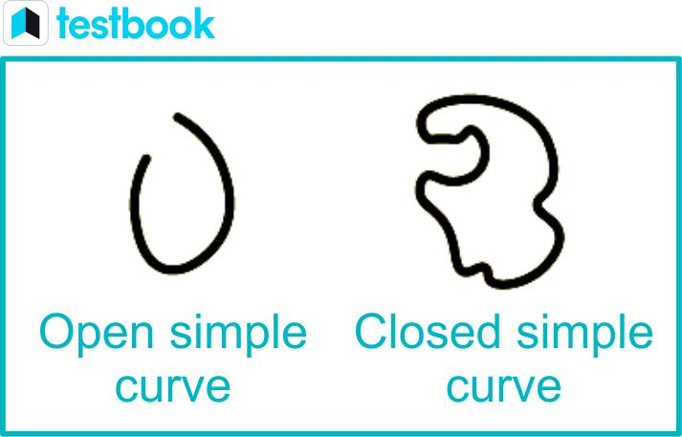
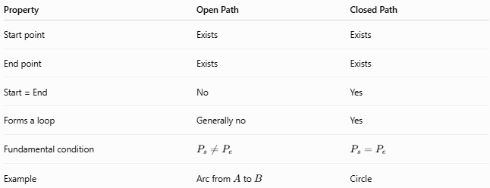
Property | Open Path | Closed Path
Start point | Exists | Exists
End point | Exists | Exists
Start = End | No | Yes
Forms a loop | Generally no | Yes
Fundamental condition | $$P_{s}≠P_{e}$$ | $$P_{s}=P_{e}$$
Example | Arc from $A$to $B$ | Circle
Therefore:
$$\boxed{\text{Open }⟺ P_{s}≠P_{e}}$$
while
$$\boxed{\text{Closed }⟺ P_{s}=P_{e}.}$$

Closed Does Not Mean Simple
# Source: AI Source: Provided by: [Data Path: Persons Table -> ID Column: 1, Name_En Column: Motasem Essam] -> From: [ChatGPT] on [7/25/2026]
A closed path can intersect itself.
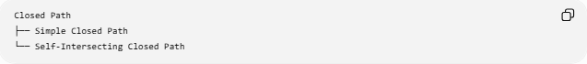
Closed Path
├── Simple Closed Path
└── Self-Intersecting Closed Path
For example:
- circle → simple closed
- ellipse → simple closed
- square → simple closed
- figure-eight loop → self-intersecting closed
Therefore:
$$\boxed{\text{Closed}⇏\text{Simple}}$$

Closed Does Not Mean Smooth
# Source: AI Source: Provided by: [Data Path: Persons Table -> ID Column: 1, Name_En Column: Motasem Essam] -> From: [ChatGPT] on [7/25/2026]
A closed path can have corners.
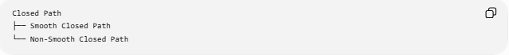
Closed Path
├── Smooth Closed Path
└── Non-Smooth Closed Path
Examples:
- circle → smooth
- ellipse → smooth
- square → non-smooth
- polygon → generally non-smooth at vertices.
Therefore:
$$\boxed{\text{Closed}⇏\text{Smooth}}$$

Closed Path and Enclosed Region
# Source: AI Source: Provided by: [Data Path: Persons Table -> ID Column: 1, Name_En Column: Motasem Essam] -> From: [ChatGPT] on [7/25/2026]
A simple closed path in the plane can form the boundary of an enclosed region.
For example:
$$\boxed{\text{Circle Boundary}→\text{Disk}}$$
The circle is the path/boundary, while the disk is the region enclosed by that path.
This distinction is important:
$$\boxed{\text{Path}≠\text{Enclosed Region}}$$
A path is typically one-dimensional, while its enclosed planar region is two-dimensional.

Length of a Closed Path
# Source: AI Source: Provided by: [Data Path: Persons Table -> ID Column: 1, Name_En Column: Motasem Essam] -> From: [ChatGPT] on [7/25/2026]
For a parameterized closed path:
$$\boxed{L=\int_{a}^{b}{\sqrt{x^{'}{\left(t\right)}^{2}+y^{'}{\left(t\right)}^{2}}} dt}$$
where
$$r\left(a\right)=r\left(b\right).$$
For a polygonal closed path:
$$\boxed{L=\sum_{i=0}^{n-1}{∣}P_{i}P_{i+1}∣}$$
with
$$P_{n}=P_{0}.$$
Example: Circle
For radius $r$:
$$\boxed{L=2πr}$$

Area Enclosed by a Closed Parametric Path
# Source: AI Source: Provided by: [Data Path: Persons Table -> ID Column: 1, Name_En Column: Motasem Essam] -> From: [ChatGPT] on [7/25/2026]
For a sufficiently regular simple closed planar curve,
$$\boxed{A=\frac{1}{2}\oint{(}\left.x dy-y dx\right)}$$
or, using a parameter $t$,
$$\boxed{A=\frac{1}{2}\int_{a}^{b}{\left(x\left(t\right)y^{'}\left(t\right)-y\left(t\right)x^{'}\left(t\right)\right)} dt}$$
with orientation determining the sign.
Example: Circle
For
$$x=r\cos{t}, y=r\sin{t},$$
over
$$0≤t≤2π,$$
the enclosed area is
$$\boxed{A=πr^{2}}.$$

Closed Parametric Path and Periodicity
# Source: AI Source: Provided by: [Data Path: Persons Table -> ID Column: 1, Name_En Column: Motasem Essam] -> From: [ChatGPT] on [7/25/2026]
A closed path does not necessarily require a periodic parameterization.
For example:
$$r\left(t\right)$$
may satisfy
$$r\left(0\right)=r\left(1\right)$$
without being periodic for all real $t$.
Therefore:
$$\boxed{\text{Closed Path}⇏\text{Periodic Parameterization}}$$
However, periodic parameterizations are very common for closed paths.

Closed Path and Loci
# Source: AI Source: Provided by: [Data Path: Persons Table -> ID Column: 1, Name_En Column: Motasem Essam] -> From: [ChatGPT] on [7/25/2026]
Many complete loci naturally produce closed paths.
Circle
$$OP=r$$
produces a closed circular path.
Ellipse
$$PF_{1}+PF_{2}=2a$$
produces a closed elliptical path.
Some loci, such as a parabola or hyperbola, are not closed.
Thus:
$$\boxed{\text{Closedness depends on the resulting locus}}$$

Classification Summary
# Source: AI Source: Provided by: [Data Path: Persons Table -> ID Column: 1, Name_En Column: Motasem Essam] -> From: [ChatGPT] on [7/25/2026]
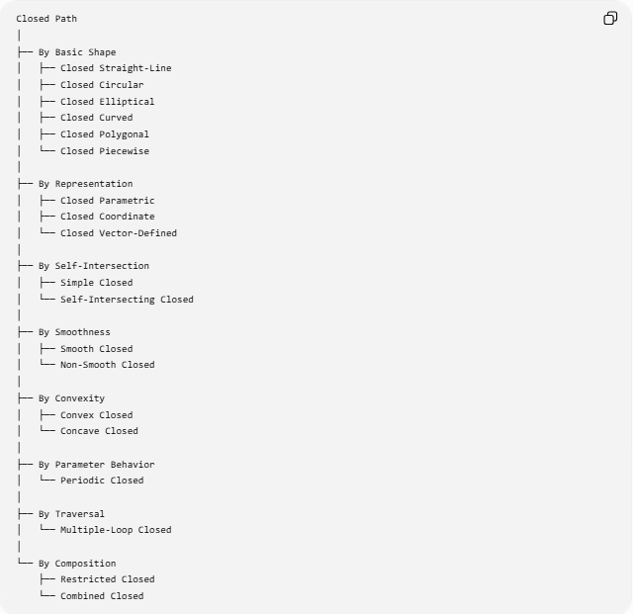
Closed Path
│
├── By Basic Shape
│ ├── Closed Straight-Line
│ ├── Closed Circular
│ ├── Closed Elliptical
│ ├── Closed Curved
│ ├── Closed Polygonal
│ └── Closed Piecewise
│
├── By Representation
│ ├── Closed Parametric
│ ├── Closed Coordinate
│ └── Closed Vector-Defined
│
├── By Self-Intersection
│ ├── Simple Closed
│ └── Self-Intersecting Closed
│
├── By Smoothness
│ ├── Smooth Closed
│ └── Non-Smooth Closed
│
├── By Convexity
│ ├── Convex Closed
│ └── Concave Closed
│
├── By Parameter Behavior
│ └── Periodic Closed
│
├── By Traversal
│ └── Multiple-Loop Closed
│
└── By Composition
├── Restricted Closed
└── Combined Closed

Key Formulas
# Source: AI Source: Provided by: [Data Path: Persons Table -> ID Column: 1, Name_En Column: Motasem Essam] -> From: [ChatGPT] on [7/25/2026]
Fundamental Closed-Path Condition
$$\boxed{P_{\text{start}}=P_{\text{end}}}$$
Parametric Condition
$$\boxed{r\left(a\right)=r\left(b\right)}$$
Polygonal Condition
$$\boxed{P_{0}=P_{n}}$$
Circular Path
$$\boxed{x=h+r\cos{t}, y=k+r\sin{t}}$$
Circumference
$$\boxed{L=2πr}$$
Parametric Arc Length
$$\boxed{L=\int_{a}^{b}{\sqrt{x^{'}{\left(t\right)}^{2}+y^{'}{\left(t\right)}^{2}}} dt}$$
Area Enclosed by a Simple Closed Parametric Curve
$$\boxed{A=\frac{1}{2}\int_{a}^{b}{(}\left.xy^{'}-yx^{'}\right) dt}$$
Periodic Parameterization
$$\boxed{r\left(t+T\right)=r\left(t\right)}$$

Key Points
# Source: AI Source: Provided by: [Data Path: Persons Table -> ID Column: 1, Name_En Column: Motasem Essam] -> From: [ChatGPT] on [7/25/2026]
- A Closed Path returns to its starting point.
- Its defining condition is:
$$P_{\text{start}}=P_{\text{end}}.$$
- For a parametric path:
$$r\left(a\right)=r\left(b\right).$$
- For a polygonal path:
$$P_{0}=P_{n}.$$
- A closed path can be straight-segment based, circular, elliptical, curved, polygonal, or piecewise.
- A closed path can be simple or self-intersecting.
- A closed path can be smooth or non-smooth.
- A simple closed planar path can form the boundary of an enclosed region.
- A circle is both a closed path and a simple smooth path.
- A polygon is closed but generally non-smooth at its vertices.
- A closed path may be parameterized periodically.
- The same geometric path can be traversed multiple times.
- Closed paths are important in geometry, topology, calculus, coordinate geometry, computer graphics, robotics, and motion planning.

Conclusion
# Source: AI Source: Provided by: [Data Path: Persons Table -> ID Column: 1, Name_En Column: Motasem Essam] -> From: [ChatGPT] on [7/25/2026]
A Closed Path is a geometric path whose final point coincides with its initial point:
$$\boxed{\text{Closed Path }⟺ P_{\text{start}}=P_{\text{end}}}$$
Closed paths can take many forms, including circles, ellipses, polygons, smooth curves, self-intersecting loops, and piecewise combinations of different geometric pieces.
The most important distinction is that closedness describes the relationship between the beginning and end of a path, not its shape, smoothness, or complexity.
$$\boxed{\text{Open Path}→P_{s}≠P_{e}} \\ \boxed{\text{Closed Path}→P_{s}=P_{e}}$$
Thus, Open/Closed should be treated as one classification dimension of geometric paths, while Straight/Curved/Polygonal/Parametric describe other dimensions.

